
COMSATS University Islamabad,
Sahiwal Campus, Pakistan.

HealthMate
AI-integrated health and fitness app

By

Aliha Minahil CIIT/FA22-BSE-004/SWL
Maira Kamran CIIT/FA22-BSE-018/SWL
Zeemal Sahoota CIIT/FA22-BSE-051/SWL

Supervisor
Mr. M Mudassir Khan

Bachelor of Science in Software Engineering (2022-2026)
Declaration
We hereby declare that this software, neither whole nor as a part has been copied out from any source. It is further declared that we have developed this software and accompanied report entirely based on our personal efforts. If any part of this project is proved to be copied out from any source or found to be reproduction of some other. We will stand by the consequences. No Portion of the work presented has been submitted of any application for any other degree or qualification of this or any other university or institute of learning.

Aliha Minahil Maira Kamran Zeemal Sahoota

Certificate of Approval
It is to certify that the final year project of BS(SE) “HealthMate – AI Integrated Health and Fitness App” was developed by Aliha Minahil (CIIT/FA22-BSE-004/SWL), Maira Kamran (CIIT/FA22-BSE-018/SWL) and Zeemal Sahoota (CIIT/FA22-BSE-051/SWL) under the supervision of “Mr M Mudassir Khan ” and co-supervisor “Ms Hafsa Saleem” and that in their opinion; it is fully adequate, in scope and quality for the degree of Bachelors of Science in Software Engineering.

Supervisor
Mr. M Mudassir Khan
Lecturer
Department of Computer Science

COMSATS University Islamabad, Sahiwal Campus

External Examiner
Dr Javeed Rashid

Deputy Registrar IT

University of Okara

Head of Department
Dr. Zafar Iqbal Roy
Assistant Professor
Department of Computer Science

COMSATS University Islamabad, Sahiwal Campus
Executive Summary
HealthMate - AI Based Health and Fitness App - is a mobile application created to give a one-stop solution in management of physical and mental health. The project will offer the increasing pressures of stress and anxiety and disjointed digital health services by incorporating a variety of wellness characteristics into a single smart platform. As opposed to the current apps, which only specialize in either physical fitness tracking or mental health, HealthMate is a unified product that integrates both aspects of digital health to provide a well-rounded and user-friendly digital solution.
The application uses physical activity tracking that requires the use of smartphone sensors but is considered a type of AI and is called a health chatbot which operates on the basis of Natural Language Processing (NLP) and is served through Gemini APIs, journaling and mood-tracking, emergency SOS, weekly reports, 3D Model-based fitness training, notifications, and rewarding motivation. Firebase provides services to ensure reliability and privacy of sensitive user data, enabling its users to have a secure authentication. Flutter and Dart were used in the application to make it compatible with Android platform.
Incremental development and continuous improvement was done by adopting an Agile (Scrum-inspired) model. The project has adhered to the usual stages of Software Development Life Cycle (SDLC) such as requirement analysis, system design, implementation, testing, and evaluation. Manual testing was used to test the functionality, integration and performance of the systems.
The end-result of this project is a scalable, secure, and smart digital wellness companion that will facilitate balanced living by ensuring integrated physical and psychological health management. HealthMate is an excellent example of the application of software engineering concepts, artificial intelligence, cloud computing and mobile application development technologies in addressing real world health issues.
The HealthMate app is an organized integration of several technologies to assist with health management. It provides a platform for physical activity monitoring, an AI-powered chatbot, journaling, recommendation of movies and songs based on detected mood and emergency assistance. The components are intended to work together to deliver a seamless user experience. Movement data can be collected with the sensors of a smartphone. Firebase provides secure user authentication and data storage in the cloud. Dart and Flutter support the app's performance on Android devices. Using an Agile development process, features of the system can be improved over time. The project follows phases of the SDLC. Each module is tested to meet specified criteria. The system balances functionality and ease-of-use. All modules support health monitoring and management. The end system maintains physical and mental health within a single system.
Acknowledgement
All praise is to Almighty Allah who bestowed upon us a minute portion of his boundless knowledge by which we were able to accomplish this challenging task.
We are greatly indebted to our project supervisor “Mr M Mudassir khan” and our Co-Supervisor “Ms Hafsa Saleem”. Without their supervision, advice, and valuable guidance, the completion of this project would have been doubtful. We are deeply indebted to them for their encouragement and continual help during this work.
And we are also thankful to our parents and family who have been a constant source of encouragement for us and brought us the values of honesty & hard work.

Aliha Minahil Maira Kamran Zeemal Sahoota

Abbreviations
AI | Artificial Intelligence
API | Application Programming Interface
CIIT | COMSATS Institute of Information Technology
HCI | Human Computer Interaction
NLP | Natural Language Processing
NoSQL | Not Only Structured Query Language
OOD | Object-Oriented Design
OOP | Object-Oriented Programming
PIN | Personal Identification Number
SDD | Software Design Description
SDLC | Software Development Life Cycle
SQA | Software Quality Assurance
SRS | Software Requirements Specification
UI | User Interface
UML | Unified Modeling Language
SOS | Save Our Souls (Emergency Alert System)

Table of Contents
1.1 Brief 3
1.2 Relevance to Course Modules 4
1.3 Project Background 5
1.4 Literature Review 7
1.5 Analysis from Literature Review (in the Context of the Project) 7
1.6 Methodology and Software Lifecycle for this project 8
1.6.1 Rationale behind Selected Methodology 9
2. Problem Definition 11
2.1 Problem Statement 12
2.2 Deliverables and Development Requirements 12
2.3 Current System 13
3. Requirement Analysis 15
3.1 Use case diagram 15
3.2 Use Case Descriptions 16
3.2.1 UC_01: registers / Login 16
3.2.2 UC_02: Chat with AI Chatbot 16
3.2.3 UC_03: Track Health Data 17
3.2.4 UC_04: View Reports and Analytics 18
3.2.5 UC_05: Receive Notifications 19
3.2.6 UC_06: Manage Journal Entries 20
3.2.7 UC_07: Emergency SOS Support 21
3.2.8 UC_08: Access AR Fitness Trainer 22
3.2.9 UC_09: Play Relaxation Game 23
3.2.10 UC_10: Mood Detection + Recommendation 23
3.2.11 UC_11: Lock / Unlock App 25
3.3 Functional Requirements 26
3.4 Non-Functional Requirements 32
3.4.1 Performance 33
3.4.2 Reliability 34
3.4.3 Security 36
3.4.4 Usability 37
3.4.5 Portability 38
3.4.6 Maintainability 39
3.4.7 Scalability 41
3.4.8 Accessibility 42
4. Design and Architecture 45
4.1 System Architecture 45
4.2 Process flow/Representation 46
4.3 Design Models 47
4.3.1 Class Diagram 47
4.3.2 Sequence Diagram for User Login 48
4.3.3 Sequence Diagram for AI Chatbot Interaction 49
4.3.4 Sequence Diagram for Health Data Collection & Dashboard Display 50
4.3.5 Sequence Diagram for Emergency SOS 51
4.3.6 State Transition Diagram 52
4.3.7 Data Flow Diagram 53
5. Implementation 56
5.1 Algorithm 57
5.1.1 User Authentication Logic 57
5.1.2 Health Tracking Logic 57
5.1.3 AI Chatbot Interaction Logic 58
5.1.4 Emergency SOS Logic 58
5.1.5 Weekly Report Logic 58
5.2 External APIs 59
5.3 User Interface 60
6 Testing 70
6.1 Manual Testing 70
6.2 Unit Testing 71
6.3 Functional Testing 72
6.4 Integration Testing 74
7 Conclusion and Future Work 77
7.1 Conclusion 77
7.2 Future Work 77
8 References 81

List of Tables
Table 1: Login table of HealthMate – AI integrated health and fitness app 28
Table 2: Use Case description of Chat with AI Chatbot 29
Table 3: Use Case description of Track Health Data 29
Table 4: Use Case description of View Reports and Analytics 30
Table 5: Use Case description of Receive Notifications 31
Table 6: Use Case description of Manage Journal Entries 32
Table 7: Use Case description of Emergency SOS Support 33
Table 8: Use Case description of Access AR Fitness Trainer 34
Table 9: Use Case description of Play Relaxation Game 35
Table 10: Use Case description of Lock / Unlock App 36
Table 11: Functional Requirements : User Registration and Login 37
Table 12:Functional Requirements — AI Chatbot 37
Table 13: Functional Requirements — Health Tracking 38
Table 14: Functional Requirements — Health Tracking 38
Table 15: Functional Requirements — Journal 38
Table 16: Functional Requirements — Notifications 39
Table 17: Functional Requirements — Analytics 39
Table 18: Functional Requirements — Fitness Trainer 40
Table 19:Functional Requirements — Relaxation Games 40
Table 20: Functional Requirements — Security 40
Table 21: API specifications in the project 57
Table 22: Manual Testing for HealthMate AI-integrated health and fitness app 65
Table 23: Unit Testing for HealthMate AI-integrated health and fitness app 66
Table 24: Functional Testing for HealthMate AI-integrated health and fitness app 67
Table 25: Integration Testing for HealthMate AI-integrated health and fitness app 68

List of Figures
Figure 1: Use Case of HealthMate – AI integrated health and fitness app 23
Figure 2: Architectural design 35
Figure 3:Process flow 36
Figure 4: Class Diagram 37
Figure 5: Sequence Diagram for User Login 37
Figure 6: Sequence Diagram for AI Chatbot Interaction 38
Figure 7: Sequence Diagram for Health Data Collection & Dashboard Display 39
Figure 8: Sequence Diagram for Emergency SOS 40
Figure 9: State Transition Diagram 41
Figure 10: DFD Level 0 Context Diagram 42
Figure 11: DFD Level 1 Core Processes 42
Figure 12: Home Dashboard Screen for HealthMate 48
Figure 13: Mood Tracking for HealthMate 49
Figure 14: Health Tracking Screen for HealthMate 50
Figure 15: Music Player Screen for HealthMate 51
Figure 16: Game Selection Screen for HealthMate 52

Chapter 1
Introduction

Introduction
This chapter gives an introduction to the HealthMate project, such as its objective, background, applicability, literature context, and methodology of development. It outlines what drives the system, what is wrong about the current situation concerning the health and wellness sector, and how HealthMate can solve the issues with the help of an unified solution. The technologies and design principles and software process model of the application development are also outlined in this chapter.
HealthMate - AI Integrated Health and Fitness App, is a mobile app that aims at helping sustain physical and mental health through one app. In the contemporary society, people experience more stress, poor lifestyle and inaccessibility to affordable mental health services. A lot of apps in the market are based on physical activity tracking or on meditation and therapy services only. Nevertheless, there is a great discrepancy in presenting an integrated solution that integrates AI-chatbot assistance with a real-time physical health monitoring system. HealthMate is created to fill this gap with the provision of an integrated and smart wellness companion [8].
HealthMate is based on the notion that Artificial Intelligence should be connected with everyday health management. Its app has several modules that include user authentication, health tracking steps, calories, health chatbot driven by AI, journaling and mood tracking, emergency SOS support, meal suggestions, 3D model fitness training, notifications and reminders, mood detection, gamification, movies and songs recommendation and weekly mental health report. The combination of these features makes the system motivate them to stay healthy at all times. The initiative has exploited the current technologies in guaranteeing efficiency and scalability. A mobile application that works with the Android platform is developed using Flutter and Dart. Firebase is a secure solution that offers authentication, real-time database, and cloud storage. The chatbot is an AI, which is connected with Gemini API, allowing users to interact with the chatbot in natural language. The system architecture is based on Object-Oriented Design with the guarantee of the modularity, maintainability, and scalability [17].
Privacy and data security are also stressed in HealthMate. As the system handles sensitive health and emotional information, end-to-end encryption and safe authentication measures are applied. The user trust and confidentiality are improved by features like App Lock, and controlled data access [6].
A critical element of HealthMate is the user-centered design, ensuring that the app is straightforward, interactive and user-friendly for a wide range of age and technology users. The app is well-organized, enabling seamless transitions between the health tracker, chatbot and fitness features. Adaptability increases engagement and retention of the application. Additionally, the gamified aspects like rewards motivate the user to follow fitness goals and build habits. HealthMate's emphasis on user-friendliness and personalized experiences offers an enriching and interactive platform.
Moreover, the software development process of HealthMate is based on the agile development approach, facilitating ongoing enhancements and quick feature releases. Continuous testing was used during development to maintain quality and functionality. The system design supports modular addition of new features in the future, such as connectivity with wearable devices and sophisticated AI data analytics. Additionally, the solution is capable of real-time data sync, ensuring real-time health monitoring. The application is scalable using cloud services, allowing it to support an increasing user base. This incremental and adaptable process guarantees that HealthMate is future-proof in the dynamic health technology environment.
Overall, the chapter tells about a new AI-based digital wellness platform called HealthMate created with the help of the latest software engineering standards. The project is supposed to provide balanced living through incorporating physical fitness tracking, mental support, emergency assistance, and motivational tools in the same secure mobile application.

Brief
HealthMate AI-Integrated Health and Fitness App is a mobile application which is designed to offer a solution to both physical and mental health management. The proposed project is aimed at the design and implementation of a safe, smart, and convenient digital wellness platform that would integrate AI-based health assistance with real-time monitoring of physical activity. The core deliverable of this project is a fully operational mobile app that enables the user to track health indicators, have an AI mental health chatbot, keep a personal journal, get recommendations, send SOS alert, and have access to motivational and gamified functionality in one system [5].
Modern technologies such as Flutter and Dart as the cross-platform mobile development framework, Firebase as an authentication and cloud-based database solution, and Gemini APIs as the means of integrating the AI-powered chatbot based on Natural Language Processing (NLP) have been utilized in the development of the application. The system architecture is based on Object-Oriented Design (OOD) principles in terms of modularity, scalability and maintainability [12].
The process of development was based on the Agile (inspired by Scrum) approach, which enabled developing modules in incremental order, including authentication, health tracker, chatbot integration, emergency support, analytics, and 3D model based fitness training. Constant testing and feedbacks were introduced to enhance the usability and performance [4].
The following report is about the entire life cycle development of HealthMate. It starts with the problem definition and literature review, proceeds with the analysis of requirements, system design and architecture, data modeling, system implementation, testing and evaluation and then finishes with the results and future improvements. The project shows how software engineering concepts and principles, integration of artificial intelligence, and development of mobile applications can be practically used to provide a full digital health solution.
Another relevant aspect of the HealthMate project relates to its focus on system stability, user interaction and improvement. The app is engineered to work seamlessly on multiple devices, be responsive and stable. The system takes into account user feedback for iterative improvements of features and system performance. The real-time notifications, reminders and progress tracking support user motivation and engagement in health activities. Additionally, the system's modular architecture enables seamless upgrades and integration of new features without compromising existing services. This enables HealthMate to be responsive, effective and respond to user and technology changes.

Relevance to Course Modules
- Software Engineering: The ideas acquired during the course in Software Engineering were put into practice during the HealthMate development. The preparation of requirements gathering, stakeholder analysis, Software Requirements Specification (SRS), and Software Design Description (SDD) was based on the academic requirements. The project was developed based on the lifecycle of Agile (Scrum based) software development, which permitted incremental development and constant improvement. Planning of the project, division of tasks, managing risks and documentation were adopted to create systematic development and quality delivery [10].
- Object-Oriented Programming (OOP): The principles of Object-Oriented Programming played a significant role in the design of HealthMate system. The classes used to organize the application were User, HealthMetric, JournalEntry, SosEvent and Reward. Basic OOP principles of abstraction, modularity, and reusability were implemented in order to have clean code architecture. This further contributed to maintainability and scalability so that various modules could operate separately, but they could not be disjointed parts of the whole system [14].
- Database Systems: The Database Systems course provided knowledge that was used in the design and management of data through the Firebase Firestore (NoSQL database). The logic was used to arrange data so that the profiles of users, their health measures, journal, and emergency could be stored. Some of such concepts implemented included data modeling, indexing, data validation and cloud synchronization. Consistency and reliability of user information was maintained by secure data storage as well as real-time database management [18].
- Artificial Intelligence (AI): The course on AI has helped to bring the chatbot that answers health related queries of users by using AI-powered by Gemini APIs. The concept of Natural Language Processing (NLP) was implemented, which allowed the user to talk to the chatbot and the latter to respond intelligently. The system accepts the user input and answers accordingly. This indicates a real-life application of the concepts of AI in solving practical wellness problems [1].
- Mobile Application Development: The Mobile Application Development course has given practical exposure to the use of Flutter and Dart that are the languages that were employed in the development of the HealthMate application. The sensor integration of devices, the development of the UI, navigation control, and the optimization of the performance methods were used to guarantee the smoothing and responsive functionality [19].
- Human Computer Interaction (HCI): Concepts acquired during the course of Human Computer Interaction were used to create an easy to use and convenient interface. The app is based on clarity, uniformity and simplicity in the design of layout. Usability had been enhanced by adding voice input and ease of navigation capabilities. The intuitive interaction provided in it means that the users of variable age groups can comfortably use the system [13].
- Software Quality Assurance (SQA): The concepts of Software Quality Assurance were used to test the system and validate it. Unit test, functional test and integration test were conducted to ensure that every module is functioning properly and integrates with other modules. Reliability and security of the system were through performance testing and validation. The practices were used to ensure high standards of software quality during the lifecycle development [3].
In general, HealthMate is a representation of the combination of various academic courses into a holistic, real-life facility, which exemplifies both theoretical knowledge and practical skills in software development.

Project Background
HealthMate AI- Integrated Health and Fitness App is created due to the growing demand of an integrated digital platform that enables both mental and physical health. In the contemporary world, people experience increased stress levels, anxiety, and lifestyle disorders because of sedentary lifestyles, pressures in their studies and work related pressures. Even though there are numerous apps available in the field of fitness tracking or meditation support, hardly any of the systems offer a single platform that would feature both emotional support and physical health monitoring in real time. HealthMate has been designed to fill this gap through the provision of an all-inclusive and technology-oriented wellness platform that encourages healthy living through a balanced and sustainable approach [17].
Beyond addressing this area, HealthMate also addresses the need for affordable and accessible health monitoring assistance. Access to health care is often limited by the cost of consultations, scarcity of professionals, and unawareness about psychological and physiological issues. Through its AI-based support and automated health monitoring, the app eliminates the need for costly professional services while offering support. The system eliminates the need for users to interact with additional health equipment and allows them to easily monitor their health through their mobile phones. This also makes it easy to use for other demographics, such as children, adults and elderly. This approach enhances HealthMate's utility in addressing contemporary health issues.
How it Works: HealthMate is a mobile application (Flutter-based) and Firebase-controlled cloud services. The system will incorporate smartphone sensors to track physical health indicators like number of calories burned and number of steps taken. Such measures are calculated and stored safely in a NoSQL database on the cloud. Simultaneously, the application will include a chatbot, powered by Artificial Intelligence, based on Gemini APIs, which employs the approach of Natural Language Processing (NLP) to understand the user input and produce responses. The system architecture is based on Object-Oriented Design approach that guarantees modularity, scalability, and safe management of sensitive health information.
How the System Works
HealthMate operating mechanism can be described in the following major operational steps:
- User Authentication: The system starts with the registration and logging in of secure users with the help of Firebase Authentication services. The authentication of user credentials is carried out, and in case it is successful access to personalized dashboard is provided. All the authentication procedures are by a secure encryption standard to secure user data.
- Health Data Collection: Physical health data, including number of calories burned, distance covered, and steps, are captured by the application with embedded smartphone sensors (e.g. accelerator where available). Data that is collected is analyzed and stored at a local computer and then synchronized with the cloud database.
- Cloud Synchronization: Firebase Firestore (NoSQL database) is a warehouse that holds the processed metrics of health and user-related data safely. Real time synchronization means the users data is always up to date and is always available in real time. Temporarily stored data are stored offline locally, and then automatically updates when an internet connection is regained.
- AI Chatbot Interaction: It has an AI-driven mental health chatbot that the users can engage with using Gemini APIs. The chatbot is based on the Natural Language Processing (NLP) to understand the input of the user, the context and provide responses. This allows active discussion to manage stress and emotional support.
- Journaling and Analytics: The system enables the users to take daily journal recordings and mood records. The system produces weekly mental health reports and daily graphical analytics based on stored health to assist users in tracking progress.
- Emergency SOS Feature: The SOS feature can be activated in case of an emergency. The system also notifies emergency contacts (predefined) instantaneously with appropriate composition of time to get help.
- Additional Wellness Features: HealthMate also offers recommendations of meals depending on the activity level. 3D model based exercise coaching, notifications and reminders as well as a gamification system to encourage regular use.
- Security and Privacy: Data transmissions and the information stored are encrypted in order to ensure confidentiality and integrity. Additional security measures like optional app-lock functionality are applied to keep sensitive information like journal entries, and health records safe.
HealthMate is an all-encompassing digital wellness companion that can aid physical and mental health, and that provides such support through the convergence of mobile sensor technology, Artificial Intelligence, and cloud computing services.

Literature Review
The recent studies and technological advances show the increasing popularity of digital health solutions to physical and mental health management. The use of mobile health applications in tracking physical activity, monitoring heart rate, and encouraging healthy lifestyle habits with wearable sensors and smartphone sensors have gained more and more popularity. Google Fit and Apple Health are among the applications that are centered on the collection and presentation of physical health metrics. In the same way, there are mental health apps such as Calm and BetterHelp that guide meditation and offer professional counseling [1]. Recent reports focus on the usefulness of Artificial Intelligence and Natural Language Processing (NLP) to provide scalable and accessible mental health services with conversational agents. But at present, the available products are typically focused on one of these areas in isolation, without a smart and intuitive product that would bring the two spheres together. Such lack of research and business implementation justifies the necessity of a common place platform such as that of HealthMate, which combines AI-based health support with real-time physical health measurement across a single secure platform [2].
A recent research trend emerging in the mobile health landscape is the design of predictive analytics and personalized health through mobile apps. State-of-the-art artificial intelligence (AI) models can now process user pattern recognition, and historical and lifestyle data to deliver timely warnings and health recommendations to users. Recent research indicates such smart health systems can enhance user engagement and long-term health by providing more personalized recommendations than generalized advice. Also, advances in cloud computing technologies and the emergence of IoT powered devices have improved data integrity and real-time synchronization in health monitoring. However, current technologies often fail to provide smooth interoperability and user-friendly experiences. This underscores the need for an integrated platform, such as HealthMate, which integrates health domains and provides multi-faceted data-driven insights in a unified and efficient manner.

Analysis from Literature Review (in the Context of the Project)
The literature review shows that existing applications in the digital health field are mostly isolated in terms of the notion of wellness by either tracking physical activity or offering mental health assistance separately. The apps like Google Fit or Apple Health are good examples of apps that use mobile sensors to track physical measurements like number of steps and calories. But these systems do not have emotional support systems or even smart interactive abilities. Conversely, applications such as Calm and BetterHelp focus on mental health with the use of guided meditation or professional counseling but lack the physical health monitoring tools and automatic AI-controlled conversational support [16]. The effectiveness of Artificial Intelligence and Natural Language Processing (NLP) in mental health interventions is also on the rise as shown in recent studies. Chatbots with the use of AI may offer affordable, scalable, and emotional support. Regardless of these improvements, the majority of the available systems either have minimal personalization or they are paid subscriptions to professional services [1].
Comparatively, in HealthMate, the two domains are combined in one integrated and unified platform. It is a physical health tracker in addition to an AI-enabled chatbot. It is not a mere static meditation application as it offers dynamic conversational support with the help of Gemini APIs. Moreover, HealthMate proposes several other functions, including emergency SOS alerts, 3D model based fitness instructions, journaling with mood analytics, and gamification, which the existing systems do not combine in one. Accordingly, according to the overview of the current research and products, HealthMate handles the specified gap as it provides a holistic, AI-assisted, and user-friendly digital wellness platform. It improves access, customization, and safety, as well as encouraging comprehensive health care.
Also, as the comparative study reveals, many current digital health systems lack a seamless integration to and ongoing feedback for the user. Existing apps tend to be isolated and users are required to navigate through varied apps to manage different health needs. This not only makes managing their health less efficient, but also leads to user fatigue and reduced engagement in the long run. HealthMate addresses this challenge by providing a seamless ecosystem where critical health services are integrated and accessible. Its smart architecture enables seamless communication between components, which helps integrate health and well-being data to support both physical and mental health requirements. This integrated approach enhances user experience and provides a holistic view of health, forming a unified perspective. In this way, HealthMate is a more integrated and efficient solution than stand-alone applications.

Methodology and Software Lifecycle for this project
The software development of HealthMate AI Integrated Health and Fitness App is based on Agile (inspired by Scrum) Software Development Lifecycle (SDLC) with Object-Oriented Design (OOD). Agile methodology was chosen to aid incremental development, flexibility, and constant improvement since the project includes various interactive modules, including authentication, integration of AI chatbot, health tracking, emergency SOS, analytics, and 3D model based fitness instructions. Agile also enables it to adapt to changes and still maintain the structure of the whole system since the requirements of the user in health related applications might change throughout the development process.
The SDLC phases utilized in this project are the following: Requirement Analysis, where the system needs were identified and documented; System Design, where architecture and UML modeling and database models were prepared; Implementation, where modules were written using Flutter, Firebase and Gemini APIs; Testing, where unit, functional and integration testing were carried out; and finally Deployment and Evaluation where the application was made to suit both academic and technical needs. This well-organized and at the same time flexible lifecycle provided systematic development without compromises in quality and reliability [20].

Rationale behind Selected Methodology
The methodology and design approach of HealthMate was selected within the framework of the requirements of the nature, complexity, and scalability of the system. The reason is as follows:
- Agile Methodology: Agile methodology was selected due to the fact that HealthMate is composed of several interdependent units, including authentication, AI chatbot, health tracking, SOS support, analytics, and 3D Model based fitness guidance. These features had to be implemented gradually and also constantly improved. Agile encourages the short development cycles (sprints), which enabled gradual development, early detection of errors, and sustained feedback by the supervisor. This incremental process reduced risks, increased flexibility to the change of requirements, and better quality of the software.
- Selection of Object-Oriented Design (OOD): The Object-Oriented Design type was chosen due to the fact that this system is organized around objects of real life like User, Healthmetric, Journalentry, Sosevent and Reward. The principles of OOD such as encapsulation, abstraction, modularity as well as reusability allowed the system to be written in a clear, orderly and maintainable way. The modules were scalable and maintainable with a long-term operation because each of the modules could be designed and tested separately, but the module was structured to be able to maintain a relationship with other parts.
- Agile and Object-Oriented Approach Integration: The integration of Agile lifecycle and Object-Oriented architecture made sure that the project was flexible, secure, and extensible. Agile also was able to offer flexibility in development and continuous improvement whereas OOD offered a good architectural structure. Such a methodological mix is specifically applicable to a mobile health application, which combines Artificial Intelligence, cloud computing, and real-time sensor data processing, in which flexibility, scalability, performance and reliability are important factors.

Chapter 2
Problem Definition

Problem Definition
The chapter outlines the essence of the problem that HealthMate is supposed to solve and describes the desired outcome of the suggested solution. It also talks about the current shortcomings of digital health systems and vividly describes the gap that the given project is aimed at addressing. Nowadays, people live in a busy and technologized world where they have to struggle more and more with issues connected not only to mental but also to physical health. Academic pressure, professional workload, and sedentary lifestyles have become the norms of high levels of stress, anxiety, absence of physical activity, and unhealthy lifestyle habits. Despite the abundance of digital health application solutions, the majority of them are either physical fitness trackers or designed to support mental wellness on their own. This disjointed system does not allow users to take care of their total well-being in a systematic and coherent way.
The current fitness apps only monitor the physical things like the number of steps, calories, and heart rate without providing emotional or psychological support. Mental health platforms, on the other hand, offer meditation programs or counseling without the inclusion of an in-the-moment physical health platform. In addition, most of the systems are not personalized, smartly interacting, and emergency support systems. This makes users use several applications to control various facets of their health, which makes them less useful, convenient, and monotonous [11]. Accessibility and affordability is another important issue. Therapy sessions offered by professionals might be costly and unavailable to most people. In addition, the user can be reluctant to talk openly about emotional problems because of social stigma. This is why the required item is a secure, intelligent, and easily usable digital platform that will incorporate the physical and the mental health management in the one system.
The projected result of this project is the creation of HealthMate, an AI-based mobile app to offer wellness holistically. The platform is supposed to provide secure user authentication, real-time physical health monitoring, mental health support, emergency SOS, journaling and analytics, and motivational capabilities in a single platform. The project will provide a scalable, reliable and accessible solution that will spur balanced and sustainable healthy living by integrating Artificial Intelligence, cloud computing, and mobile sensor technologies [7].
One of the fundamental aspects of the proposed solution is its emphasis on creating trust and commitment to its ongoing use by providing a safe and adaptive ecosystem. HealthMate aims to safeguard personal user data, and maintain privacy and confidentiality in interactions. The solution also tailors interactions to users based on their activities and emotional responses, providing tailored guidance and feedback. This makes the experience more relevant and engages users to continue using the system. The use of smart feedback and tracking mechanisms keeps users informed of their progress. This helps to achieve short-term as well as long-term lifestyle goals and general well-being.

Problem Statement
Academic pressure, workload in professions, sedentary habits, and ignorance regarding healthy lifestyles have exposed individuals of modern society to mental stress, anxiety, and physical health issues induced by lifestyles. Although there are already plenty of digital health applications, the majority of the currently available systems are focused on a single aspect of wellness, be it the tracking of physical activity or offering mental help on its own. This disjointed strategy makes users incapable of taking charge of their general well-being in a holistic and efficient way.
Fitness tracking apps mostly track physical data including the number of steps made, calories burned, and heart rate yet do not include emotional support and smartness of interaction. On the contrary, there exists a trend of mental health platforms that offer meditation content or professional counseling services with no real-time monitoring of physical health or automated assistance by AI. Moreover, a lot of current systems do not have emergency SOS, and safe management of sensitive health data [9].
It thus follows that there is need of a single, safe, and smart digital platform which unites both physical and mental health maintenance into one application. The gap that the proposed project attempts to fill is the lack of an all-encompassing AI-based mobile application that can offer real-time health monitoring, a talking assistant, emergency response, and tailored wellness data in a safe and convenient way. It is suggested that a holistic and technology-based approach to the present-day health management could resolve this issue, and HealthMate is offered.

Deliverables and Development Requirements
This part describes both the physical deliverables of HealthMate project and the technical and development aspects that need to be adequately addressed in order to achieve successful implementation.
Deliverables
The major project deliverables are:
- A mobile application (HealthMate) functioning with android platform.
- Software Requirements Specification (SRS) document on non-functional and functional requirements.
- Software Design Description (SDD/SSD) documentation that consists of system architecture, UML, and data design.
- And Final Year Project Report with fully prepared as per the university template.
- UML diagram such as Use Case Diagram, Class Diagram, Sequence Diagrams, State Transition Diagram, and Data Flow Diagrams (DFDs).
- Testing records such as unit testing reports, functional testing reports and integration testing reports.
- Application build and deployment ready source code.
Development Requirements
To develop the HealthMate system successfully, the following technical requirements were found:
- Development Platform: Flutter platform based on DART and developed with cross-platform mobile applications.
- Backend Services: Firebase authentication, real-time database (Firestore), and cloud storage.
- Artificial Intelligence Integration: Gemini APIs (Flash Model 1.5) of AI-powered chatbot with Natural Language Processing (NLP) operation.
- Hardware Requirements: Smartphone with at least 4GB of RAM, inbuilt sensor (accelerometer and the internet connection).
- Software Requirement: Android 8.0 or higher to use the application.
- Security Requirements: Authentication of users, encrypted transmission of data and storage of sensitive health and journal information.
These deliverables and development specifications will guarantee that the project is both technically viable, academically conforming and that the project can address its functional goals without compromising its security, scaling and performance standards.

Current System
At the present, the majority of digital health apps are either physical fitness trackers or mental health aids only. Smartphone apps like Google Fit and Apple Health can track the number of calories, steps or heart rate, but they lack support, emotional, or psychological. On the other hand, such a mental wellness application as Calm or BetterHelp does not provide physical health monitoring on the spot but can provide meditation or counseling.
Also, there are plenty of features like AI-based conversational support and emergency SOS notifications, gamification, and 3D model based fitness in one system, among many others, which are absent in most existing systems. Consequently, users have to use numerous applications to take care of various areas of their health [15]. This shows the lack of the existing system scenery: the lack of a combined, smart, and safe mobile application that would offer both physical and mental health management. The HealthMate is supposed to solve this shortcoming by offering a single digital wellness product.

Chapter 3
Requirement Analysis

Requirement Analysis

Use case diagram
The health mate system is a use case diagram that depicts how the user interacts with the key functions of the application. It recognizes the user as the main actor and is able to do many things including registration and login, health tracking, communicating with the AI chatbot, controlling the journal entries, accessing analytics, and initiating emergency SOS help. The diagram also indicates the presence of external systems like Firebase to authenticate and manage data, and Gemini API to communicate with the chatbots using AI. In general, the use case diagram offers a graphic depiction of the functionality of a system, interaction among users, and the scope of the HealthMate application, which can assist in learning how various modules can co-exist. The diagram also aids in understanding the interconnections between use cases and how user interactions can result in system behaviour. It offers insight into the system's boundaries, showing what is accomplished within and what requires interaction with external systems. This organized view helps in the design, verification of requirements, and communication between the system stakeholders during development.

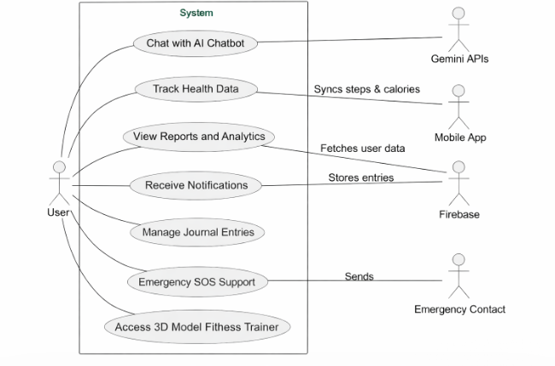

Figure 3.1.1: Use Case of HealthMate – AI integrated health and fitness app

Use Case Descriptions

UC_01: registers / Login
This use case outlines the way a user registers or logs into the HealthMate application through a secure authentication. The user is provided with valid credentials which are authenticated by Firebase Authentication system. After a successful verification, the user will have access to the dashboard where all the features of the application can be accessed. It also provides secure synchronization of user data and preferences. Should there be any error like invalid credentials or network problems, then the relevant messages are shown, and a password recovery option is offered. The system provides session management in order to maintain the user session and avoid malicious attacks
Table 3.2.1.1: Login table of HealthMate – AI integrated health and fitness app
Use Case ID: | UC-1
Use Case Name: | Register / Login
Actors: | Primary Actor: User  Secondary Actor: Firebase Authentication System
Description: | The user creates a new account or logs into the existing HealthMate account. Upon successful authentication, the user gains access to the dashboard where all features are available. The Firebase service validates credentials and synchronizes user data securely.
Trigger: | The user opens the app and selects either “Register” or “Login.”
Preconditions: | PRE-1: The application is installed and connected to the internet.  PRE-2: User has valid registration details (email and password).
Postconditions: | POST-1: User authentication is verified and access granted.  POST-2: User profile and preferences are synced from Firebase.
Normal Flow: | 1. The user selects Register/Login.  2. The system displays the respective form.  3. The user enters credentials and submits.  4. Firebase validates details.  5. The system loads the dashboard upon success.
Alternative Flows: | A1: Forgot Password: The user requests a password reset; Firebase sends an email for reset.
Exceptions: | E1: Invalid credentials entered → Display “Invalid login.”  E2: Network connection lost → Display “Unable to connect to server.”
Business Rules: | BR-1: Passwords must be at least 8 characters long.
Assumptions: | A1: Most users prefer using email authentication.

UC_02: Chat with AI Chatbot
The following use case describes how a user can engage a chatbot with AI to get mental health assistance, motivation, and self-care advice. The user enters the messages via text or voice and the Gemini API responds to them via Natural Language Processing (NLP). The system then creates the corresponding responses and presents them to the user. This is done through secure communication and error handling makes the communication flow smoothly in case of a connectivity or system failure.
Table 3.2.2.1: Use Case description of Chat with AI Chatbot
Use Case ID: | UC-2
Use Case Name: | Chat with AI Chatbot
Actors: | Primary Actor: User  Secondary Actors: Gemini API, Firebase
Description: | The user interacts with an AI-powered chatbot for mental health support, motivation, and self-care advice. The Gemini API processes queries using NLP and returns appropriate responses.
Trigger: | The user selects “Chat with AI” from the dashboard.
Preconditions: | PRE-1: The user must be logged in.  PRE-2: Internet connection must be active.
Postconditions: | POST-1: Chat conversation is displayed to the user.
Normal Flow: | 1. The user opens the chatbot interface.  2. The user enters a message or speaks via mic.  3. The system sends the input to Gemini API.  4. The API processes and returns a response.  5. The system displays the message.
Alternative Flows: | A1: User uses voice input for communication.
Exceptions: | E1: No internet connection – show offline message.  E2: Gemini API timeout – show “Please try again later.”
Business Rules: | BR-1: The chatbot cannot provide medical advice.  BR-2: All communication is encrypted end-to-end.
Assumptions: | A1: Each chat session is independent of previous ones.

UC_03: Track Health Data
This use case explains how the system tracks and logs the physical health-related activities of the user including the number of steps, calories burnt and distance covered. It relies on the in-built smartphone sensors such as accelerator to gather real-time data. The data obtained is then processed and normalized and stored safely in Firebase. The system makes sure that there is synchronisation of data between the local storage and cloud database. On the dashboard, users can access their daily health statistics to track progress. This is useful in keeping the user fit, encouraging healthy lifestyles and in constant monitoring of health. The system will provide weekly activity report to enable users to review their exercise behaviour. The use of visuals like charts also helps users to interpret their activity and realistically plan their fitness goal. Additionally, the system helps users maintain consistency in their fitness journey by providing continuous progress tracking and personalized insights based on their activity data. This feature enables users to monitor their overall physical health effectively and stay motivated to achieve their fitness goals.
Table 3.2.3.1: Use Case description of Track Health Data
Use Case ID: | UC-3
Use Case Name: | Track Health Data
Actors: | Primary Actor: User  Secondary Actors: Firebase
Description: | The app collects physical activity data such as steps, calories, and heart rate from built-in sensors and stores it securely in Firebase.
Trigger: | The user opens the Health Tracking module or data syncs automatically.
Preconditions: | PRE-1: Device sensors are active.
Postconditions: | POST-1: Data is stored locally and synchronized with Firebase.  POST-2: Dashboard is updated with new stats.
Normal Flow: | 1. The system retrieves health metrics from sensors.  2. Data is processed and normalized.  3. Values are displayed and synced.
Alternative Flows: | A1: Partial tracking if permissions are limited.
Exceptions: | E1: Sync failure, retry automatically.
Business Rules: | BR-1: Data collection respects battery optimization.
Assumptions: | A1: Users sync daily for accurate tracking.

UC_04: View Reports and Analytics
This use case describes how users can see detailed reports and analytics using their health and activity information. The system accesses data stored in Firebase and works on it to create valuable insights. It
the information graphically in form of charts and summaries in a way that can be easily understood. The reports can assist users in tracking patterns in their physical and mental well-being. Users are able to analyze their performance and make wise judgments in an effort to change their ways of life. This characteristic improves data visualization, user-awareness, and long-term interaction with the application. It helps users improve their health over time by keeping a track.
Table 3.2.4.1: Use Case description of View Reports and Analytics
Use Case ID: | UC-4
Use Case Name: | View Reports and Analytics
Actors: | Primary Actor: User  Secondary Actor: Firebase
Description: | This use case describes how the user views detailed reports and graphical analytics of their fitness and wellness progress. The system retrieves stored health data such as step count, calorie burnt. Firebase, and visualizes it through charts. The feature helps users monitor progress over time and set new goals for improvement.
Trigger: | The user selects the “Analytics” or “Reports” option from the screen.
Preconditions: | PRE-1: The user must be logged into the application.  PRE-2: Health data must be available in the Firebase database.
Postconditions: | POST-1: The system successfully retrieves user data and displays it as interactive charts or statistics.
Normal Flow: | 1. The user navigates to the Analytics section.  2. The system requests the user’s stored health and wellness data from Firebase.  3. Data is processed and formatted into visual charts (weekly).  4. The analytics report is displayed on screen.
Alternative Flows: | A1: If no data is found, the system displays a message: “No activity data available”.
Exceptions: | E1: Data fetch error: If the system fails to connect to Firebase, it displays “Unable to load reports. Please check your internet connection.”
Business Rules: | BR-1: Reports must be updated automatically once new data is synced.  BR-2: All analytics visualizations must refresh.
Assumptions: | A1: Users regularly sync their data so that analytics remain up to date.  A2: Users may prefer simplified visuals on smaller screens.

UC_05: Receive Notifications
This use case explains how the system will send a reminder and notification to maintain users consistent to their health routines. The notifications can be hydration notifications and sleep notifications. Firebase Cloud Messaging (FCM) is employed to provide dependable and prompt provision of notifications. The system also enables the user to customize the notification settings. It makes sure that the notifications are not too frequent to overload the user. This aspect serves to remind users of being in a healthy routine, and enhances the overall user experience within the application.
Table 3.2.2.1: Use Case description of Receive Notifications
Use Case ID: | UC-5
Use Case Name: | Receive Notifications
Actors: | Primary Actor: User  Secondary Actor: Firebase Cloud Messaging (FCM)
Description: | This use case describes how HealthMate sends timely reminders and motivational alerts to the user. Notifications include hydration and sleep reminders. Firebase Cloud Messaging handles the scheduling and delivery of notifications. The goal is to keep users engaged and consistent with their health routines.
Trigger: | The system scheduler or a specific health event triggers a notification (e.g.,daily reminder time reached).
Preconditions: | PRE-1: The user must be logged in to the application.  PRE-2: Notifications must be enabled in app settings.  PRE-3: Internet connection must be available for real-time notifications.
Postconditions: | POST-1: Notification is delivered to the user’s device.
Normal Flow: | 1. The user configures notification preferences (e.g., reminders for hydration, sleep).  2. The system monitors scheduled times.  3. When a trigger condition is met, a notification is generated.  4. Firebase Cloud Messaging delivers the notification to the user’s device.
Alternative Flows: | A1: User disables notifications: The system temporarily stops sending alerts.
Exceptions: | E1: Invalid or expired device token: Notification delivery fails silently; Firebase retries automatically.
Business Rules: | BR-1: Notifications must not exceed 15 per day to prevent user fatigue.  BR-2: Notifications should respect local device “Do Not Disturb” settings.
Assumptions: | A1: Most users prefer morning or evening reminders.

UC_06: Manage Journal Entries
This use case shows how users can create, edit, and manage personal journal entries in the HealthMate application. Users are able to document their thoughts, feelings and activities on a daily basis in an organized manner. All entries are safely stored in Firebase to create privacy and accessibility of data. The system can support mood tagging to enable the users to monitor changes in emotions over time. Entries can be edited or deleted by the user and give flexibility. The feature helps in mental health awareness, self-reflection, and emotional well-being. The repository provides secure storage and access control to the data so that only the user is able to view and update data.
Table 3.2.6.1: Use Case description of Manage Journal Entries
Use Case ID: | UC-6
Use Case Name: | Manage Journal Entries
Actors: | Primary Actor: User  Secondary Actor: Firebase Database
Description: | This use case describes how the user creates, edits, views, and deletes personal journal entries within HealthMate. The feature supports both the text and voice input, enabling users to record their emotions, daily reflections, or self-care notes. Each entry is securely stored in Firebase, ensuring data privacy and accessibility across sessions. Users can also categorize entries based on mood or activity for better insight into mental health trends.
Trigger: | The user selects the “Journal” option from the main dashboard.
Preconditions: | PRE-1: The user must be logged into the HealthMate application.  PRE-2: The app must have permission to store and access local or cloud data.
Postconditions: | POST-1: The journal entry is successfully stored or updated in Firebase.
Normal Flow: | - The user opens the Journal section.  - The system displays existing journal entries.  - The user creates a new entry.  - The user saves the entry.  - The system encrypts and uploads the entry to Firebase for secure storage.  - The entry becomes visible in the list view with the associated date and mood tag.
Alternative Flows: | A1: User is offline: The entry is saved locally and synced automatically when internet connectivity is restored.  A2: User deletes an entry: The system prompts for confirmation and permanently removes the record from Firebase.
Exceptions: | E1: Network error: The entry remains in local cache until successful synchronization.
Business Rules: | BR-1: All journal entries must be encrypted before cloud upload.  BR-2: Only the logged-in user can view or edit their own entries.
Assumptions: | A1: Users will use journaling for daily reflection or stress management.

UC_07: Emergency SOS Support
This application scenario explains how the users can send emergency notifications to preconfigured contacts in emergency cases. The system sends an alert to the emergency contacts of choice by pressing the SOS button and the system triggers an immediate alert. The system maintains fast communication with limited connectivity as it tries to reconnect in case of necessity. It can have simple information like time and phone number of the user when activated. This will be a safety feature which will offer emergency help when needed. It has a list of emergency contacts which can be updated by the user. It increases the reliability and trust of the user in the application during emergencies.
Table 3.2.7.1: Use Case description of Emergency SOS Support
Use Case ID: | UC-7
Use Case Name: | Emergency SOS Support
Actors: | Primary Actor: User  Secondary Actor: Emergency Contact, Firebase
Description: | This case describes how the HealthMate app enables the user to send an emergency alert to predefined contacts in critical situations. By pressing the SOS button, the system sends an alert message to the registered emergency contacts. The feature ensures immediate communication in case of health emergencies, or emotional distress.
Trigger: | The user presses the SOS button on the emergency screen.
Preconditions: | PRE-1: The user must have configured emergency contacts in the settings.
Postconditions: | POST-1: An emergency alert is successfully sent to all configured contacts.
Normal Flow: | - The user opens the Emergency screen.  - The system displays the SOS button.  - The user presses the SOS button.  - The system sends the alert message to registered contact.  - A confirmation message appears once the alert is successfully sent.
Alternative Flows: | A1: No internet connection: The app queues the message and sends it once connectivity is restored.
Exceptions: | E1: Contact list empty: The app prompts the user to configure contacts before using SOS.
Business Rules: | BR-1: The SOS feature must bypass “Do Not Disturb” mode for immediate delivery.  BR-2: Only verified emergency contacts should receive alerts.
Assumptions: | A1: The user has pre-added valid emergency contacts.  A2: Users will use the feature responsibly and only during real emergencies.

UC_08: Access AR Fitness Trainer
The following use case describes the way in which users can get guided workouts using 3D animated fitness models. The system shows a virtual trainer who shows exercises step by step. There are various workout programs that may be chosen by users like stretching, yoga, or fitness programs. The visual instructions assist users to do exercises properly and safely. The system gives it an easy rendering and interaction to enhance user experience. This aspect encourages physical activity and enhances interaction with users by learning.
Table 3.2.8.1: Use Case description of Access 3D Fitness Trainer
Use Case ID: | UC-8
Use Case Name: | 3D model based Fitness Trainer
Actors: | Primary Actor: User  Secondary Actors: 3D model
Description: | This use case describes how the user accesses and interacts with the 3D model based Fitness Trainer in the HealthMate app. The feature displays the 3D model as a virtual trainer on-screen who demonstrates workout routines.
Trigger: | The user selects the “3D Fitness Trainer” option from the home.
Preconditions: | PRE-: The user must be logged into the application.
Postconditions: | POST-1: The 3D model displayed on the screen of the user.
Normal Flow: | - The user opens the 3D Fitness Trainer module.  - The app initializes the model.  - The user selects a workout routine (e.g., yoga, cardio, stretching).  - The virtual trainer appears on-screen demonstrating the exercises.
Alternative Flows: | A1: Low-light environment: The user must improve lighting for better understanding of the exercise being demostrated.
Exceptions: | E1: 3D model failure: The app may fail to display the 3D model on the screen.
Business Rules: | BR-1: All the sessions must not be too long to prevent overheating and fatigue.
Assumptions: | A1: Users will use the 3D trainer in a safe and open environment.

UC_09: Play Relaxation Game
This use case explains how users can access and play inbuilt relaxation games that help in alleviating stress. These are easy, interactive games and aimed at enhancing mental health. The system is easy to navigate to choose and start games. Users will be able to have a brief game to unwind and rejuvenate. The games are non-violent and user friendly. It is a feature which improves the user experience by providing mental health support and entertainment.
Table 3.2.9.1: Use Case description of Play Relaxation Game
Use Case ID: | UC-9
Use Case Name: | Play Relaxation Game
Actors: | Primary Actor: User  Secondary Actor: Firebase Database
Description: | This use case describes how the user accesses and plays built-in relaxation games designed to reduce stress and improve mental well-being. The games are lightweight and interactive for relaxation and positive engagement.
Trigger: | The user selects the “Game” option from the main dashboard or self-care section.
Preconditions: | PRE-1: The user must be logged into the HealthMate application.  PRE-2: Internet connection is required to load game.
Postconditions: | POST-1: User plays the selected game.
Normal Flow: | 1. The user opens the Relaxation Game module.  2. The system loads available relaxation games (e.g., breathing exercise).  3. The user selects a game and starts the session.
Alternative Flows: | A1: User exits the game.
Exceptions: | E1: Game loading failure: The app displays “Unable to load game. Please check your connection.”
Business Rules: | BR-1: Games must be non-violent, age-appropriate, and designed to reduce stress.  BR-2: Game sessions should not exceed 20 minutes to maintain user focus and avoid fatigue.
Assumptions: | A1: Users will play relaxation games voluntarily as part of stress management.  A2: The app may add new games in future updates for enhanced engagement.

UC_10: Mood Detection + Recommendation
In this use case, the application enables users to detect their emotional state through AI-based mood detection using facial image analysis. Users can capture a photo using the device camera. The system processes the image using a mood detection model to identify emotions such as happiness, sadness, stress, or neutrality. Based on the detected mood, the application provides movie and song recommendations to enhance the user's emotional well-being and entertainment experience. All image processing and recommendation data are handled securely to protect user privacy and ensure a trustworthy user experience.
Table 3.2.10.1: Use Case description of Mood Detection and Personalized Recommendations
Use Case ID: | UC-10
Use Case Name: | Mood Detection and Personalized Recommendations
Actors: | Primary Actor: User  Secondary Actor: DeepFace Emotion Detection API, Recommendation Engine, Firebase
Description: | The application allows users to detect their current mood by analyzing facial expressions from an uploaded image. The user s captures an image, which is processed by the DeepFace emotion recognition model to identify the dominant emotion. The detected emotion is then mapped into broader mood categories such as Happy, Sad, or Neutral. Based on the identified mood, the system provides personalized song and movie recommendations to enhance the user's emotional well-being and entertainment experience. All image processing is performed securely, and temporary image files are deleted after analysis to protect user privacy and ensure data security.
Trigger: | The user selects the "Mood Detection" feature from the dashboard.
Preconditions: | PRE-1: The user must be logged into the application.  PRE-2: Internet connection must be active.
Postconditions: | POST-1: The user's mood is successfully detected.  POST-2: Movie and song recommendations are displayed to the user.
Normal Flow: | 1. The user opens the Mood Detection interface.  2. The user Captures an image for analysis.  3. The system temporarily stores the uploaded image.  4. The DeepFace model analyzes the image and detects the dominant emotion.  5. The detected emotion is mapped to a mood category (Happy, Sad, Neutral).  6. The system retrieves movie and song recommendations based on the detected mood.  7. The system recommends movies and songs.
Alternative Flows: | A1: If the detected emotion does not match predefined categories, the system may show error.
Exceptions: | E1: Emotion detection fails – display an appropriate error message and request the user to try again.  E2: The captured image does not contain a clearly detectable face – continue processing using DeepFace's relaxed detection settings or provide neutral recommendations.
Business Rules: | BR-1: Recommendations must only be generated after successful mood detection.  BR-2: Mood detection results are intended for supportive and entertainment purposes only and do not constitute medical or psychological diagnosis.
Assumptions: | A1: The DeepFace model can accurately identify dominant emotions from facial expressions.  A2: Recommendation data for songs and movies is available for each supported mood category.

UC_11: Lock / Unlock App
In this use case, the application will guarantee data security by means of lock and unlock mechanism. When launching or resuming the application, users are asked to enter a PIN to access the application. This helps avoid unauthorized users to gain access to sensitive data like health records and journal entries. The system implements authentication and can lock access temporarily in case of multiple unsuccessful attempts. Handling of all authentication data is done in a secure way to ensure misuse. This aspect enhances privacy, data security and confidence of the user to the system.
Table 3.2.11.1: Use Case description of Lock / Unlock App
Use Case ID: | UC-11
Use Case Name: | Lock / Unlock App
Actors: | Primary Actor: User  Secondary Actor: Firebase Authentication
Description: | This use case describes how the HealthMate application ensures user privacy and data security through app locking and unlocking mechanisms. The system allows users to secure access using a PIN code. Upon launch or when the app resumes after inactivity, the user must successfully authenticate before accessing sensitive information like journal entries or health reports.
Trigger: | The user launches the application or returns after a period of inactivity.
Preconditions: | PRE-1: The user must have registered a valid PIN.  PRE-2: The device must support the chosen security method (PIN).
Postconditions: | POST-1: If authentication is successful, access to the app and user data is granted.  POST-2: If authentication fails, access remains restricted..
Normal Flow: | - The user opens or resumes the HealthMate application.  - The system prompts the user to unlock the app using PIN.  - The user provides authentication credentials.  - The system verifies credentials via Firebase.  - Upon successful verification, the dashboard and all features are unlocked.
Alternative Flows: | A1: Authentication fails: The system prompts the user to enter the PIN again.
Exceptions: | E1: Unlock Failure: The app locks temporarily fails.
Business Rules: | BR-1: The system must auto-lock after closure of app to ensure privacy.  BR-2: Authentication data must never be stored in plain text.
Assumptions: | A1: The users preferably use PIN to unlock app.

Functional Requirements
Functional requirements are those requirements that a system such as the HealthMate system should carry out to satisfy the user needs. These requirements define the behaviour of the system when interacted with by the user and also the basic functionalities of the application. Within the case of HealthMate, functional requirements encompass the following features: user authentication, AI chatbot interaction, health tracking, emergency support, and data analytics. All the requirements make the system provide a hermetic and effective user experience and help manage both physical and mental health. To make things clear and well organized, the various application features are presented individually and have their own functional requirement table. Such systematic method also provides traceability of the system features and the respective requirements to enable easier system design, implementation and evaluation.
HealthMate's functional requirements also ensure that each system module delivers its specific operation in conjunction with other modules. Username, password, and credentials ensure security and prevent unauthorized access to system functions. Chatbot interaction with AI involves the chatbot listening to user messages and responding using appropriate AI services. Health monitoring capabilities capture and display user activity in a structured manner for monitoring. Emergency services ensure that user actions such as SOS are performed immediately on activation. These requirements help ensure consistent system behavior in response to user actions.
Each functional requirement is also defined by inputs, processes and outputs to ensure a clear understanding of the system. Analytics features analyze health data to produce summary reports and visualizations. The system coordinates the operation of all functionality through effective data communication. Functional decomposition is used to simplify complex operations into smaller parts for efficient system development. This methodology helps minimize system uncertainty and enhances development processes. It also facilitates the testing of each function in the system evaluation stage.
3.3.1 User Registration and Login
This module allows one to create an account using the HealthMate application in a secure way. It secures appropriate authentication of user credentials and authentication through Firebase services. The system also has the passwords recovery and secure session management to defend user information. This functionality is the gateway to any system capabilities. User registration guarantees that the application is used only by legitimate and verified users. Firebase Authentication services verify the credentials of the user during registration and login. It stores secure data related to the login process. It also manages sessions, validating that users are logged in while the application is in use. For invalid credentials, relevant error messages are shown.

Table 3.3.1: Functional Requirements : User Registration and Login
FR ID | Priority | Actor | Requirement Description
FR-1.1 | High | User | The user shall be able to create an account using email and password.
FR-1.2 | High | System | The system shall validate user input (email format, password strength) before registration.
FR-1.3 | High | User | The user shall log in using valid credentials.
FR-1.4 | Medium | System | The system shall provide password recovery via email verification.

3.3.2 AI Chatbot Interaction
The module enables the user to communicate with an AI-powered chatbot about mental health support and advice. The chatbot tries to interpret user input via Gemini API using Natural Language Processing (NLP). It answers user queries in real-time, leading to a sense of emotional well-being. The system provides fault-free and safe communication between the user and AI service. The chatbot preserves the conversation flow by taking into account the user queries in relation to the current conversation. It ensures that the responses are aligned to the user's conversational context. It also optimizes user input processing to eliminate latency and improve chatbots' performance. The module is also capable of processing a number of user queries without disrupting communication.
Table 3.3.2:Functional Requirements — AI Chatbot
FR ID | Priority | Actor | Requirement Description
FR-2.1 | High | User | The user shall interact with the chatbot via text or voice input.
FR-2.2 | High | System | The system shall process user input using Gemini API (NLP).
FR-2.3 | High | System | The system shall generate relevant responses based on user queries.
FR-2.4 | Medium | System | The chatbot shall provide motivational and mental health support (non-medical).

3.3.3 Health Tracking
This module monitors physical health activities of the user, including the number of steps and calories. It takes advantage of smartphone sensors to gather real-time information and process it effectively. The data obtained is safely stored in Firebase and presented to the user in the dashboard. This is an excellent feature that allows users to monitor their fitness. Continuous updates of health statistics are maintained through the system, which makes the data readily accessible on the dashboard. It manipulates the data collected from sensor to ensure the updated information is accurate and consistent before being published to the user. The data stored in Firebase is structured for easy access and use. The module provides real-time updates so that the module detects changes in the activity. It also takes care of data processing securely and safely to facilitate continuous monitoring.
Table 3.3.3: Functional Requirements — Health Tracking
FR ID | Priority |  | Actor | Requirement Description
FR-3.1 |  | High | System | The system shall track steps using device sensors.
FR-3.2 |  | High | System | The system shall calculate calories burned.
FR-3.3 |  | Medium | System | The system shall store health data in Firebase.
FR-3.4 |  | Medium | User | The user shall view daily health metrics on dashboard.

3.3.4 Emergency SOS Support
This option allows users to send instant alerts to emergency contacts which are predefined. It provides prompt communication in emergencies because it causes notifications in the shortest time possible. The system is capable of storing emergency information and delivering even when the network is unstable. This improves safety and reliability of the application to the user. The message is sent immediately when the user chooses the option. It dynamically reads the list of emergency contacts to send the message to the right person. The emergency data is accessed, to enable immediate action in emergency scenarios. The message is sent in a systematic way to ensure delivery of message.
Table 3.3.4: Functional Requirements — Health Tracking
FR ID | Priority | Actor | Requirement Description
FR-4.1 | High | User | The user shall trigger an SOS alert using a button.
FR-4.2 | High | System | The system shall send alerts to predefined contacts.
FR-4.3 | Medium | System | The system shall store emergency logs in database.

3.3.5 Journal and Mood Tracking
This module provides an option of journal entries of daily thoughts, feelings and activities. It allows mood tagging to enable users to track their mood patterns over time. All the entries are safely kept in the database to ensure privacy. This aspect helps in enhancing mental health awareness and self-reflection. The journal entries are properly structured to facilitate access to past entries. It ensures uniform storage of each entry so that none of the information is misplaced or lost. They can see their previous entries to analyze feelings and actions over time. The records are fetched from the database in an effective manner. It also records the data of the journals with their corresponding user for effective management.
Table 3.3.5: Functional Requirements — Journal
FR ID | Priority | Actor | Requirement Description
FR-5.1 | High | User | The user shall create journal entries.
FR-5.2 | Medium | User | The user shall edit or delete entries.
FR-5.3 | Medium | System | The system shall store journal data securely.
FR-5.4 | Medium | System | The system shall associate mood tags with entries.

3.3.6 Notifications
This module makes the user to be engaged by reminding and giving alerts to them in time. Alerts are hydration, sleep. Firebase Cloud Messaging is employed in sending notifications effectively. This assists users to continue with their health behaviors. The notifications are sent in an organized and timely manner ensuring users don't miss their notifications. It has appropriate scheduling so that the events are delivered as required. Users will receive the notifications even under network fluctuations due to Firebase Cloud Messaging. The messages are displayed properly so the users can quickly comprehend the notifications. It also makes sure that all reminder messages are kept up-to-date with system to ensure smooth functioning.
Table 3.3.6: Functional Requirements — Notifications
FR ID | Priority | Actor | Requirement Description
FR-6.1 | Medium | System | The system shall send reminders (hydration, sleep).
FR-6.2 | Medium | System | The system shall use Firebase Cloud Messaging for notifications.

    - Analytics and Reports
The module offers the user visual information about his or her health and wellness. It uses stored data to produce weekly reports and daily graphics. The analytics assist the users to comprehend the trends and make wise health choices. This enhances user awareness and involvement. The framework fetches data from Firebase to make sure all reports are produced using the up-to-date information. It organizes the data to produce summaries. The visualizations enable easy comparison of weekly performance. The displays are consistent when it comes to presenting health information. It also ensures the information it provides is in line with the user’s activities for clarity.
Table 3.37: Functional Requirements — Analytics
FR ID | Priority | Actor | Requirement Description
FR-7.1 | High | System | The system shall generate weekly health reports.
FR-7.2 | Medium | System | The system shall display data using charts.
FR-7.3 | Medium | User | The user shall view analytics dashboard.

3.3.8 3D Fitness Trainer
This capability offers the user guided workouts using 3D animated models. It assists users in doing exercises in the right manner by visually showing how to do these exercises. The system has a smooth rendering of models to provide a better user experience. This improves physical activity and interaction in the application. The module shows workout instructions in a sequential manner for the user to perform exercises. It supports the visual demonstration to be continuous throughout the workout. It interprets the chosen workout instructions to be displayed. Users can use the visual instructions to ensure the right posture. It also allows for the interaction between the user and workout flow to enhance understanding.
Table 3.3.4: Functional Requirements — Fitness Trainer
FR ID | Priority | Actor | Requirement Description
FR-8.1 | Medium | User | The user shall access 3D workout sessions.
FR-8.2 | Medium | System | The system shall display animated exercise models.

3.3.9 Game Module
This module provides relaxation games, which help to reduce stress levels and enhance mental health. The games are easy, interactive and simple to use. They offer respite to regular activities and encourage healthy interactions. Such a feature adds to the general user experience and emotional balance. The games are easily accessible to allow users to play them without complicated instructions. They enable brief gameplay that can be incorporated into daily life. The module is responsive for continued interaction while playing. It supports users to replace their focus of everyday stressors with simple tasks. It also offers a consistent user interface for a familiar feel.
Table 3.3.9:Functional Requirements — Relaxation Games
FR ID | Priority | Actor | Requirement Description
FR-9.1 | Medium | User | The user shall play relaxation games.
FR-9.2 | Medium | System | The system shall provide stress-relief game options.

3.3.10 Mood Detection and Recommendation
This module provides AI-powered mood detection and personalized entertainment recommendations to support users' emotional well-being. The feature analyzes users' facial expressions from uploaded images to identify their current emotional state. Based on the detected mood, the system suggests suitable songs and movies to improve mood, reduce stress, and enhance the overall user experience. The recommendation process is simple, interactive, and easy to use, allowing users to receive personalized content without complex interactions. The module ensures secure handling of uploaded images by processing them temporarily and removing them after analysis to maintain user privacy. It provides a responsive and consistent user interface, enabling users to access mood-based recommendations conveniently as part of their daily self-care routine. This creates a more engaging and emotionally supportive experience by helping users discover content that matches their evolving mood patterns.

Table3.3.10 : Functional Requirements — Mood Detection and Recommendation
FR ID | Priority | Actor | Requirement Description
FR-10.1 | High | User | The user shall capture an image for mood detection.
FR-10.2 | High | System | The system shall detect the user's mood from the uploaded image.
FR-10.3 | Medium | System | The system shall provide movie recommendations based on the detected mood.
FR-10.4 | High | System | The system shall display an error message if mood detection fails or an invalid image is uploaded.

3.3.11 App Lock and Security
This module guarantees users privacy of their sensitive data by providing secure authentication. It enables one to lock an application with a PIN to access it sparingly. The system uses encryption method to secure information stored. This increases privacy and user confidence in the application. The authentication process makes sure only valid users are granted access to the application system upon login. It also keeps the access to the application controlled to avoid unauthorized access. It involves secure session management to prevent unauthorized use of sessions. It handles all confidential information securely. It further makes sure that various security measures are in place while using the application.
Table 3.3.11: Functional Requirements — Security
FR ID | Priority | Actor | Requirement Description
FR-10.1 | High | User | The user shall lock the app using PIN.
FR-10.2 | High | System | The system shall enforce authentication before access.
FR-10.3 | High | System | The system shall encrypt sensitive data.

Non-Functional Requirements
The quality attributes, performance and operational constraints of HealthMate application are defined by non-functional requirements. Non-functional requirements are different to functional requirements, which outline the functionality of the system, but provide information on how the system works under different conditions. These requirements are essential to ensure that the application is efficient, reliable, secure, and user-friendly. They also contribute to an increase in user satisfaction, system stability and long-term scalability and maintainability. The HealthMate system will address these needs to ensure smooth and uniform experience to every user.
HealthMate's non-functional software requirements also concern reliability and availability for continued use. The system should be stable without any unexpected behaviour or crashes. It must efficiently process different user requests in various scenarios. It is important to maintain a reasonable response time to allow uninterrupted interaction with users and system components. It should be able to handle high volumes of health and activity data, without being compromised. Appropriate resource management is needed to prevent burdening the device or server. These requirements assist in creating a stable and dependable application platform. Dependability is an important element of user satisfaction.
Another non-functional requirement relates to the performance efficiency, which refers to the system's responsiveness. HealthMate should be able to provide timely responses to user actions through efficient data processing. It should have low latency when switching between modules of the application. Data processing mechanisms need to facilitate flawless health monitoring and analytics. Limited memory and processing should be used to avoid performance degradation. It should achieve the same performance on all devices. Performance is critical as it allows users to interact seamlessly. This leads to improved user experience and system effectiveness.
Other non-functional requirements of the HealthMate system are security and maintainability. User data must be protected against any unauthorzed access to maintain security. Authentication controls are needed to ensure access control. It must be flexible in terms of updates and modifications without compromising the existing features. The code should be structured in a manner that facilitates efficient maintenance and development. Data integrity needs to be maintained during data operations. Periodic maintenance and updating should not interfere with the system's operation. These guidelines enable the system to be sustained and operated securely.

Performance
The system will offer high performance. This is essential to ensure seamless and real-time communication between the user and the AI chatbot since the lag in responding to messages can adversely impact the experience and interaction with the user. The system is also optimized to process user requests in an efficient manner by reducing the processing time and latency. Moreover, other features, including health tracking and data synchronization, are made to run without any perceptible delays by the application. Effective performance not only enhances usability, but also user satisfaction and confidence in the system.
It also guarantees that its performance is independent of load. It can handle multiple requests without affecting the interactivity of core features. It ensures that processing user's input does not slow user interactions. Data processing operations are designed to run efficiently. It optimizes processing costs to achieve performance across the system. Memory factors are controlled to prevent unwelcome delays in long tasks. It aims to be performant in low as well as high usage operations. This also guarantees fast and reliable response.
Another key component of performance is also the system operations between system components. It efficiently controls the flow of all the activities within the system. It ensures flow of information is not blocked between processes. The system aims to be un-interrupted whilst in use. It employs optimization techniques for best system operation. The system remains responsive to user interactions. It also ensures uninterrupted operations while processes are running. This ensures optimum system operations.
The other element of system performance is the data interaction between the app and other services. It ensures optimal data operations with Firebase and AI service. The network data is operated efficiently to minimize latency. The app processes data streams without interruption. It maintains performance levels during user data synchronization. It reduces unnecessary processing to reduce system load. It is optimized to not consume user input. It controls the flow of execution to ensure execution of time-sensitive processes. It ensures synchronization of all parts. Tasks are managed to ensure smooth function-to-function co-ordination. It avoids bottlenecks with load balancing. It also ensures efficiency with parallel processing. The app offers a uniform execution environment. This results in a speedy system operation. It allows for an efficient prolonged operation.
The system also seeks to ensure efficient operations through process control. It controls the time taken for various functions so that the process is done in the alloted time. It ensures that interactions between modules are properly controlled. It guarantees that the system is not interrupted while in use. This ensures that operations are not in conflict. It maintains consistent and high-speed data among components. It avoids performance bottlenecks with load balancing. It ensures all processes are completed without compromises to responsiveness. A stable system environment is maintained. It optimizes resource management. Interactions with it are smooth. It delivers continuous responsiveness. The design supports effective concurrent operations. The system is thus stable and easy to use. It ensures the desired performance level.

Reliability
The application will be highly reliable in the sense that it will have a system uptime of about 99%. This implies that the system must be up and running with minimal downtimes. To do this, the application is designed with a strong error handling system, fault tolerance, and recovery systems that enable the system to identify and remedy the errors quickly. The system must have the capability of recovering itself automatically in instances of temporary failures without causing much inconvenience to the user. Health-related applications are particularly sensitive to reliability as users require 24/7 access to their information and key capabilities. This is a necessity to maintain stability, reliability and availability of the system.
Another factor that enhances the reliability of the application is its consistent performance. When the application is exposed to higher user loads or processing requirements, it remains responsive. This reliability guarantees that users can rely on the application without any breaks in service. The modular design enables the system to handle its operations effectively and remain stable. It reduces the risk of unexpected errors by managing processes properly. It monitors itself to identify anomalies in its operation. This allows it to detect problems before they occur and avoid service disruptions. This helps ensure system reliability. Users can access their data with confidence, knowing it's secure.
The application prevents abrupt crashes by managing processes. It coordinates the various parts. This minimizes the risk of failure. This creates a reliable user environment. The system is, therefore, stable and reliable during normal operation. Further, the software makes sure any problems that arise are addressed in an efficient manner. The system's error handling features mean that it can deal with problems without significant disruption. Rather than crashing, the system segregates the error and keeps working if possible. This reduces the effects of errors on the user experience. Any temporary faults are handled in a way that users may not even be affected. It aims to ensure service continuity at all levels. It logs and corrects errors as soon as possible. This prevents the recurrence of problems.
The application's error-handling process increases its reliability. The software is less likely to malfunction. The app continues to operate with minor problems. This is crucial for user satisfaction. It is a characteristic of a sound system design. In the end, the system is resilient to faults. A further aspect of reliability is the quick recovery from failures. The application aims to return to normal operation with minimal manual intervention. For temporary failures, the system will automatically start recovery. This restores services as quickly as possible. This helps reduce disruption to users. It also avoids loss of information. It guarantees that operations are not disrupted. Automatic recovery processes run in the background. It allows continuous operation of the application. This feature is essential for uninterrupted service. The system ensures that recovery is quick. It prevents problems from coiling out of control. Self-recovery enhances the application's resilience. It helps to establish the required reliability.
So, seamless operation is ensured. In addition, the reliability of the application is crucial to the system's function as a health system. There is a reliance on users being able to access their data and key functions. Potential outages could impact their ability to access the system. So, availability is a critical requirement. The system has been designed to work around the clock with minimal downtime. It allows users to access it whenever they need to. This contributes to trust and reliability. The system is designed to be stable. It steers clear of risk factors that affect availability. It aims for reliable and predictable performance. Reliability is seen as a fundamental characteristic. The system guarantees that users will not be denied access in a critical situation. This ensures the application is dependable when needed. In short, reliability helps the system meet its objectives.

Security
This system will guarantee security is high as it will incorporate end to end encryption of all the user data including personal information, health records, and even journal entries. This helps keep data secure during transmission and storage, avoiding unauthorized data access or data breaches. The app employs intensive authentication tools including Firebase Authentication, to authenticate the user, and then authorize them to access the system. Furthermore, sensitive information is kept in the use of secure cloud storage, and only authorized users have access to it. The system also makes sure that user credentials are not saved in plain text and adheres to common security measures to keep confidentiality, integrity, and data protection. This is a necessity in order to develop user trust and adherence to data privacy.
The system's security is also enhanced through the protection of data at all times. User data is encrypted from its creation until it is stored or transmitted. This ensures that data remains secure throughout its journey. The system tightly controls data exchanges between components. It ensures data cannot be intercepted in the communication process. And by protecting data during transmission and storage, it prevents data loss. The app adopts uniform data protection measures. Data is carefully handled throughout interactions. This allows users to trust the system and avoid any concerns about safety. Vulnerabilities are eliminated in the design. Protective measures are consistently in place. This enhances the security of the app. A safe environment is provided to users. Data confidentiality is maintained. In general, security is provided throughout all transactions.
Here, the authentication process is also key to ensuring system security. By using Firebase Authentication, only registered users are able to access the system. This procedure stops hackers from accessing the system. Users are verified before they can use any features. The system verifies user credentials. This helps prevent misuse and abuse. Access control measures allow only authorized users to access the data. User authentication is managed securely. It enhances the verification of the user's identity. The system avoids inefficient authentication methods. The user can be confident that their account is secure. This enhances user security. The process is stable and predictable. It provides a solid defence against attacks. Authentication contributes to the security of the system.
In addition, user credentials' management is aimed for maximum security. The system prevents storing login credentials in clear text. This helps prevent the leakage of credentials even if the system is compromised. Secure handling of credentials keeps user accounts protected. The app adheres to best practices for handling login information. It prevents storing data in a vulnerable manner. This helps enhance security against login attempts. Credential handling and storage is tightly controlled. It safeguards users against vulnerabilities related to poor data handling. It guarantees the security of credential-related tasks. This helps to build user confidence. It reduces the risk of account theft. The system ensures these protections remain in place. All credential operations are secure. In sum, user data is protected.
Also, secure cloud storage guarantees that only approved users may access sensitive data. It has robust access control measures in place. This protects the privacy of personal and health data, and journal entries. Permissions effectively prevent unauthorised access. The storage system ensures data integrity and confidentiality. It prevents data from being changed or used inappropriately. Data access to storage is secure. It has a separation of access controls. This organization improves data security. The system can be trusted to protect information. The app maintains privacy. It helps meet general data protection requirements. Data storage continues to be secure. It continues to provide a secure environment. In short, user data is well protected.

Usability
The app will offer an easy to use interface that will be easy, intuitive and easy to navigate by all users. The design is designed to be clear, consistent and minimally complex to make the users easy to comprehend and interact with the system without having to have technical knowledge. Features such as clear icons, structured layouts, and responsive design are incorporated to enhance usability. The interface should be user-friendly to users of various ages, such as beginners by limiting confusion and enhancing ease of use. Also, the system will provide seamless flow of activities between various modules enabling users to work effectively. This is a prerequisite that will improve the satisfaction of users and make them use the application frequently.
The user interface is designed to provide clarity for each user action. The layout of each screen is designed to display information in a clear and accessible way. This helps prevent users from feeling bombarded when using the app. The elements are presented in a sequence that corresponds to user expectations. It is easy for users to perceive what to focus on. The layout does not present extraneous information that can be distracting. The system has a uniform look and feel throughout. This allows users to quickly adapt to the system. This makes it easier for new users to learn. Icons and layouts are consistent. This enables users to interact confidently. The interface allows for immediate action. They enjoy an efficient interaction. The design aids in task performance. Clarity is a guiding principle of the design.
Users can easily navigate through the system to various sections. It is easy to navigate from one part of the application to another. The design keeps key options readily available. This allows them to achieve their goals efficiently. The flow of navigation facilitates natural task progression. There's no need to memorize complicated routes and commands. The design makes it easy to navigate between modules seamlessly. This provides a seamless user experience. The system minimizes the possibility of users becoming disorientated. Users can easily identify and navigate sections. The system keeps related functions together. It aids in the comprehension of the app's structure. It improves efficiency in performing tasks. Users know how the navigation works. It is easy to navigate and use.
The application's visual design aids usability for all users. Icons are used to convey actions and features in a meaningful manner. This allows users to easily identify functions without verbose descriptions. The layouts help present information in a coherent way. This helps users quickly grasp information. There is no clutter to distract or overwhelm. It balances the presentation of elements. This balance supports readability and interaction. It is easy to use by people of all ages. The interface is intuitive and does not demand technical know-how. It is suitable for both novice and experienced users. Visuals are easy to understand. It allows for easy interaction. The user interface is accessible. This guarantees a good experience for all users.
The flow of the activities in the application promotes quick and seamless user interaction. Activities are linked in the flow. It enables users to perform tasks in a seamless manner. This ensures that features are seamlessly connected. There are no interruptions or inconsistencies for users. The flow is designed to be efficient and time-saving. This allows users to accomplish their tasks. The app provides flow in user's actions. Each action leads to the next. This eliminates confusion and improves user-friendliness. The system enables a continuous process. The app is always able to work effectively. It promotes use through its simplicity. It improves user satisfaction through simplicity. The app is efficient and user-friendly.

Portability
The system will be portable and will be able to run on Android devices in general and a wide variety of android smartphones and screens in particular. Flutter and Dart are cross-platform technologies, on which the application is built, which enable flexibility and the need for homogenous performance across the devices. This makes sure that users have no compatibility problems with using the application, irrespective of the device specification under the Android versions supported. The system will be able to cope with the differences in hardware and software settings without compromising performance and functionality. This aspect enhances the availability and functionality of the application, which can serve a larger population of users with its functions.
Portability of the system ensures that it works on a number of Android devices. The application will run equally well on different types of users with different models of smartphones. It is compatible with various screen resolutions. This allows the user interface to be readable on different sizes. It makes sure that content is properly aligned in different resolutions. There are no stretching or cropping problems in the app. The application has a uniform interface. The app is not frustrating to users across devices. The product has consistent performance in the target environment. It avoids device-specific issues that can affect the user experience. The app is self-adjusting. This ensures consistent behavior. Users enjoy a consistent interface. The system is fast and responsive. Thus, portability leads to platform-invariant behavior.
The use of Flutter and Dart mean that the app will run as well on different versions of Android. Flutter provides consistency across different versions. It helps to avoid inconsistencies. The system is robust with software changes. The app is consistent on various devices. The design enables a shared code base. This prevents device-specific features. The app solves the Android fragmentation issue. It offers a universal user experience. The system is robust irrespective of the configuration. This simplifies compatibility issues. There are no speed issues. The application works the same on all devices. It is consistent in different environments. The experience is consistent and reliable.
It is hardware sensitive but not hardware dependent. The system can operate on devices with varying processing abilities. The application adjusts its operations according to resources. The system can work without any glitches on the device. It ensures the system does not use excessive resources. It offers efficiency across all devices, even low-end devices. It allows users to access all the features. It provides consistent performance. It eliminates performance problems caused by hardware differences. It enhances the app's processes for responsiveness. This ensures responsiveness for users. The approach enables resource sharing. The app is reliable on all devices. Users enjoy continuous operation. Generally, the system is not slowed down by different hardware.
The portability of the system also renders it more user-friendly. The system is not restricted due to compatibility. The system is compatible with different versions of Android operating system. This ensures that the system is not affected by software incompatibilities. The system provides the same features on every device. There is no need for installations. This increases the number of users. The application is device independent. The application offers a uniform user experience. There are no restrictions on the system. It enables the application to run in all devices. This provides equal system access. Users can access the system. It allows system portability. In short, portability enhances accessibility and usability.

Maintainability
The app will be implemented through a modular and well-designed design methodology in order to guarantee easy maintenance and later scalability. Object-Oriented Design principles are used to develop the system in which various features of the system like user management, health tracking, chatbot integration, and data management are isolated into distinct modules. This will enable programmers to update, debug or improve certain sections of the system without altering the functionality of the system. Correct documentation, coding guidelines and version management are also observed to facilitate maintainability in the long term. This is necessary so that the system can be dynamic to future technological developments and can be enhanced effectively as time goes by.
The modular framework of the system means that each module has its own responsibility and functionality. This enables developers to work on one module at a time without affecting others. Modularity simplifies the development and maintenance process. Modules have well-defined responsibilities within the system. This enhances the system's understandability. Developers can easily find and work on parts of the application. Modularity avoids side effects when updating the system. It guarantees that updates affect only the specific area. It facilitates effective debugging through isolation. Problems can be diagnosed and fixed without impacting the whole system. Modularity leads to cleaner, clearer code. It makes it easier to manage complex code. It's easier to maintain the system as it grows. Consistency between modules can be maintained. This enhances the application's reliability. Interactions between the modules are well-managed. It ensures stability during changes. It keeps the system well-organized. In short, modularity makes development easier. It helps ensure system maintenance.
Applying Object-Oriented Design principles enhances the organization and reusability of the system. The application is broken down into features, with each one having its own characteristics and actions. It enables a reasonable organization of the system. And it facilitates the reuse of features where appropriate. The code is better organized using classes and objects. This makes it easier to comprehend and maintain. The architecture helps to arrange related functions. This improves the code's readability and maintainability. It allows for code reuse and extension of existing components. The system can be scaled due to its structure. It ensures simplicity by using design patterns. It is open to future enhancements. It eliminates code duplication through the use of Object-Oriented principles. It helps keep development process efficient. The system ensures features are implemented consistently. This method enhances teamwork. Different components of the system can develop separately. The system can be grown in a controlled manner. It allows the system to be flexible. In summary, Object-Oriented Design provides a robust design.
Good documentation and coding practices help ensure the system is understandable. Documentation can be used to understand how the system works. It allows the system to be independent of individual expertise. It also makes the system more maintainable, even by new developers. Coding standards make sure that the entire application is consistent. This makes the code easier to read and understand. It prevents non-standard coding practices that may become confusing. Documentation aids in understanding interactions between modules. It offers directions for making changes. Programmers can adhere to clear patterns for changes. This helps reduce bugs. The system has a systematic development process. Version control allows for changes to be managed. It allows for changes to be managed. Old versions can be restored as needed. This provides further stability to the system. Documentation keeps the application well-organized. It's easy to maintain over time. The system remains stable during its evolution. So, documentation and standards enhance maintainability.
It should be adaptable to the changing technology without re-engineering the entire system. It is modular for the purpose of enhancements. It allows for modules to be changed without affecting the rest of the code. This enables the apps to be responsive to changing requirements. It makes it possible to continue to make improvements. The system stays up-to-date with technology. It's not set in its ways. It allows easy integration of enhancements. Programmers can make enhancements to features. The design is scalable and adaptable. It can expand in size. It can be modified without impacting performance. This allows seamless upgrades. Users can still use the software. It encourages best practice development. It facilitates evolution with minimal complexity. It allows for improvements without loss of performance. The system is stable during transition. In short, the system will be effective over time.

Scalability
The system will be tested to be scalable such that it can support up to 10,000 simultaneous users without causing a noticeable performance loss. The application utilizes cloud-based devices like Firebase services, which allow allocation of the resources dynamically and efficient management of the increased workloads. The system is capable of scaling horizontally, handling numerous user requests at a time as the number of users increases. This guarantees them uniform performance, fast response and continuous service even when it is in peak usage. The ability to scale is needed to support the further development and increase the number of users of the HealthMate application.
The system's scalability means that its performance will not degrade as more users are added. The application's design allows it to handle growth without compromising performance. The processing of user requests is enhanced to prevent bottlenecks. Workload is spread out to avoid bottlenecks. This prevents bottlenecks and enables uninterrupted operation. It delivers stable response times for users no matter the load. Resources are efficiently used at all times. It prevents bottlenecks from limiting system performance. It enables tasks to run seamlessly under load. It enables unbroken user interaction with the application. The approach is to preserve efficiency under load. It supports multiple concurrent sessions. The system continues to operate well even with a large user base. This enhances system reliability. It continues to be responsive under heavy loads. It prevents performance degradation impacting users. The design allows for predictable performance
. Users have uninterrupted access. The system supports growth with no loss of performance. In general, scalability ensures system effectiveness. By leveraging cloud technologies, such as Firebase, the system can scale resource allocation to demand. Resources are scaled to the number of users. This prevents the system from using more resources than needed. It also guarantees that there are enough resources to support high traffic. The application is self-adaptive and does not require tuning. This enables ongoing operations across different scenarios. It can manage the balance between resource and performance. It guarantees efficient processing. The cloud platform enables effective load management. It eliminates the risk of overloading. The app can adapt to varying demands. This responsiveness improves overall reliability. The system will not fluctuate in performance. It provides an uninterrupted user experience. It prevents excessively long waiting times. It allows services to run uninterrupted. The system supports consistent functionality. Resource allocation is improved. Overall, dynamic allocation enhances scalability.
Horizontal scalability of the system means it can accommodate increasing user requests. It allows for multiple requests to be processed simultaneously at the same speed. It distributes work to ensure efficiency. It avoids bottlenecks at any point. It enables timely response to user requests. The system allows multiple users to operate simultaneously. This is crucial to responsiveness. The response time remains consistent regardless of the load. There is no impact on the user experience. It can be scaled without modifying its design. It is stable when performing multiple tasks. It can handle a large amount of data and requests. All processes are efficient. It provides uninterrupted user experience. There are no delays during peak loads. It provides a uniform service. Large-scale use is supported. It has a consistent performance. In all, horizontal scalability is effective. Scalability is an important element in the growth of the application. The system seamlessly supports a growing number of users. This guarantees the application will continue to work for everyone. The architecture enables growth without affecting performance. It facilitates ongoing development as users increase. The system can still accommodate for future growth. This allows for future growth in usage. The design delivers the same level of service as the system grows. There is no difference in the user experience. There are no bottlenecks that limit expansion. It accommodates more users without compromises. The system remains user-friendly and reliable. This ensures the system will be able to adapt. It enables future development and improvement. It enables the system to adapt without disruption. Service to users is uninterrupted as the system evolves. It is resilient and flexible. It operates efficiently throughout its growth. In short, scalability leads to sustainability.

Accessibility
Accessibility will also be incorporated in the application so that they can be well utilized by those people with varying capabilities including the physically or visually challenged. A variety of features, like voice commands, big buttons, readable text, and easy navigation, are incorporated to make the device more usable to everyone. Readability and ease of interaction are the main concerns of the interface design, such that users can use all functionalities without any inconvenience. The system will also help minimize complexity and offer inclusive design features that can meet the needs of different users. This is a condition that encourages equal access to the application and helps to make health and wellness services accessible to a broader population.
The accessibility design allows users with varying physical or visual impairments to easily use the application. The architecture is built to accommodate accessible use of all features. All features are easy to interact with. Users have easy access to the tools they need. The design emphasizes clarity of the elements on the screen. This makes it easier to comprehend and operate the software. Interactions are straightforward. There is no confusion or additional steps. There is consistency in the user interface across sections. It doesn't overwhelm users, which could make the system inaccessible. The app emphasizes accessibility to all functions. This enables a comfortable user experience. The design provides a continuous access to users. The user is not limited by physical and visual impairments. It offers a fair and sensitive design solution. It provides equal opportunities to all users. The system is a user-friendly application for different users. It facilitates easy interaction under all circumstances. Accessibility is built-in.
The use of voice commands improves the accessibility of the app for those with limited access to conventional input devices. Users can provide voice commands to the system. They can use application features without having to navigate them. Voice input is used to trigger actions. This minimizes the need for interaction with the device. Users gain flexibility to use the app. The feature is useful for people with disabilities. It enables easy access to main functions. Voice commands are easy to understand. It allows users to accomplish their tasks. The interaction method enhances usability. It offers another method of navigation. It provides reliable interpretation of user commands. This enables the actions to be performed. Users enjoy a user-friendly interface. The app offers multiple interaction options. It boosts access to features. It is reliable in offering control. In summary, voice commands boost accessibility.
The application is accessible due to the use of legible text and large buttons. Users can read and comprehend information on the screen. Legible text enhances the reading experience for everyone. Sizable buttons can be clicked easily. This helps users make the right choices. The design guarantees readability and visibility. There's no need for users to squint. The system provides feature segregation. This enables users to find options easily and efficiently. The system is visually uncluttered. It doesn't clutter the screen. All features are easily accessible. It makes it easier to find key features. This enhances user-friendliness for different audiences. The environment facilitates easy interaction with visuals. It provides a uniform look and feel. There is ease of navigation. It is easy to comprehend. In summary, legibility and large buttons ensure accessibility.
The system ensures that it is easy to navigate for all users. Users can easily navigate through various parts. It ensures that user interaction is not confusing. Access to each function is made convenient. This facilitates ease of use. The structure of the interface doesn't have an overly complicated structure. Users can easily reach features. The system provides a coherent navigation between modules. This makes it easier to navigate through the app. All features are easily accessible. The system allows users to perform tasks easily. The system aims to lessen user difficulties. It facilitates a simple and intuitive design. It supports easy navigation throughout the system. The user experiences interaction with multiple modules. The design promotes inclusivity by catering to user diversity. It provides equal access to all features. The system is easy to use by all. In short, navigation aids accessible inclusivity.
The system ensures that accessibility features are integrated to meet the needs of all users. All the interface components contribute to ease of recognition and manipulation. All users can carry out the required tasks. The app also has a consistent level of simplicity. This reduces the complexity of use. The aim is to provide health and wellness services for all. It ensures equal engagement for all users. The application supports effective and inclusive accessibility.

Chapter 4
Design and Architecture

Design and Architecture

System Architecture
The high-level architectural design of HealthMate illustrates a layered mobile application structure consisting of a User Interface layer, Application Logic layer, and Data layer integrated with cloud services and AI APIs. The system communicates with device sensors for health tracking, an AI service for chatbot interaction, and a cloud backend for secure data storage and synchronization. The system architecture promotes interaction between the layers in the system. The User Interface layer clearly displays information and accepts input from users. The Application Logic layer handles user interactions and system operations. The Data layer stores and retrieves information via the cloud. The interaction between the layers is well-organized. Health data from device sensors is input to the system. This is then sent to the application logic for processing. The AI service powers the chatbot interactions, handling user requests and providing responses. Data is securely stored and synced by cloud back-end services. Data consistency is maintained during data transfers. Different layers do not interfere with each other. This aids in understanding system behavior. It ensures controlled and predictable data flow. It enables consistent communication between mobile and cloud. Data collected for health tracking is managed effectively. The system keeps interactions with AI connected with user data if needed. Cloud connections ensure data is current across interactions. It enables seamless interaction among system components. In summary, the architecture allows for structured functioning of HealthMate.

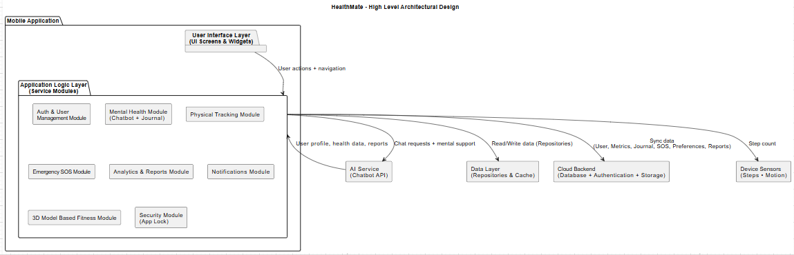
Figure 4.1.1: Architectural design

Process flow/Representation
The process flow diagram illustrates the sequential operation of HealthMate, from user login and dashboard access to AI chatbot interaction, physical activity tracking, emergency SOS handling, and viewing analytics reports.
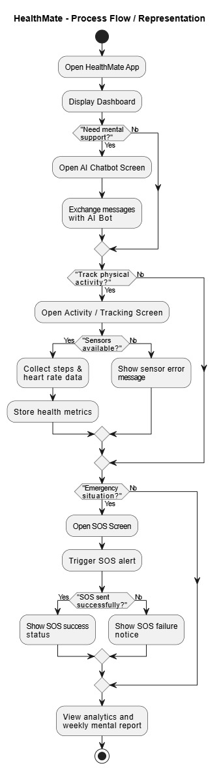
Figure 4.2.1: Process flow

Design Models
The structural and behavioural design of the system is offered in this section and modelling techniques are used accordingly. The documentation will include a Class Diagram, sequence Diagrams, State Transition Diagram, and Data Flow Diagrams (DFD -Level 0 to Level 2) because HealthMate is going to be designed with the help of an object-oriented design approach. All these diagrams help to depict the interaction among various components as well as the flow of data through the system and the change of system state upon user actions. The class diagram illustrates the structure of the system by displaying the relationships of the classes in the system. It aids in the understanding of the user management, health monitoring, chat bot integration and data management system. The sequence diagrams show the sequence of interactions between objects in particular scenarios. The diagrams illustrate how messages are passed from one object to another. The state transition diagram illustrates how the system transitions from one state to another in response to user actions. It illustrates the impact of various conditions. Data Flow Diagrams - Level 0, Level 1 and Level 2 - outline the flow of data. It helps to envision input, process and output phases. The diagrams help to understand the system. The modelling approaches help to visualize the system design. They help to document the system structure and behavior. In summary, the diagrams together depict the entire system.

Class Diagram
The representation of the static structure of the HealthMate system is the class diagram that shows the different classes, their attributes and methods, and their relationship. The design has key classes, which include User, HealthMetric, JournalEntry, SOS, and Reward. The model depicts the principles of object-oriented, i.e., encapsulation, inheritance and association. It helps visualize the organization of data, communication between different components of the system at the code level.

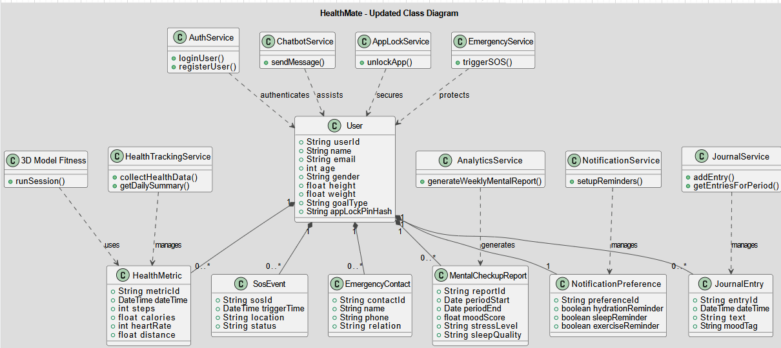
Figure 4.3.1.1: Class Diagram

Sequence Diagram for User Login
The following boxes correspond to the interaction of the elements of the system in the process of user login in this sequence. It shows how the user will input the credentials to the system to log in, and it will be verified with the Firebase Authentication. Upon successful validation, the system accepts the user and takes him to the dashboard. The figure highlights the messages that move between the other services in the background and the user interface. The sequence diagram is a good representation of the login scenario. The process starts with the user input in the system interface. The input is sent from the user interface to the authentication service. The credentials are sent to Firebase Authentication. It waits for the response from the authentication service. If the input is valid, a success message is returned. This is returned to the system. The user's identity is then verified. Once confirmed, user is granted access. The user is taken to the dashboard. The user interface is refreshed to show the user is logged in. The sequence of messages is indicated. Events are triggered in a sequential manner. The diagram allows to understand the authentication process. It illustrates the relationship between user interaction and server validation. It allows access only to authenticated users. Access is denied until verification. Service interaction is well-organized. The flow concludes with the dashboard being shown to the user.

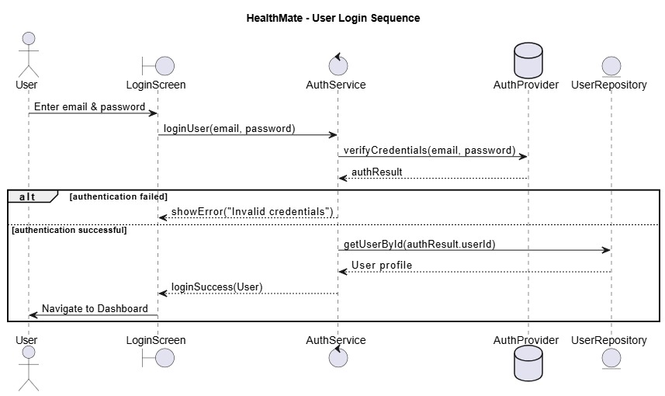
Figure 4.3.2.1: Sequence Diagram for User Login

Sequence Diagram for AI Chatbot Interaction
This flow chart is a list of activities between the user and the AI chatbot. The user makes a query, and it is transferred to the Gemini API where it is processed using NLP. The API produces response, which is shown to the user. The diagram is eloquently used to show the communication between the user interface, system processing and external API. The activity diagram below shows the user's interaction with the AI chatbot in a step-by-step fashion. It starts with the user entering a request via the user interface. This is passed to the system for processing. The system then passes the query to the Gemini API. The API uses natural language processing to interpret the query. It will interpret the meaning of the request. Once it has processed the request, it then responds. This is then provided to the system. The response is then returned to the system. The response is then displayed to the user. The sequence of operations is in the correct order. Interactions between components are depicted. The interaction guarantees processing of user input. It provides a link between the interface and the API. The direction of information is governed. It demonstrates the relationship between each step of communication. The response generation is dependent on the processed query. The output is shown only if the process is completed. The diagram shows the entire communication cycle. The cycle is completed when the user gets the response.
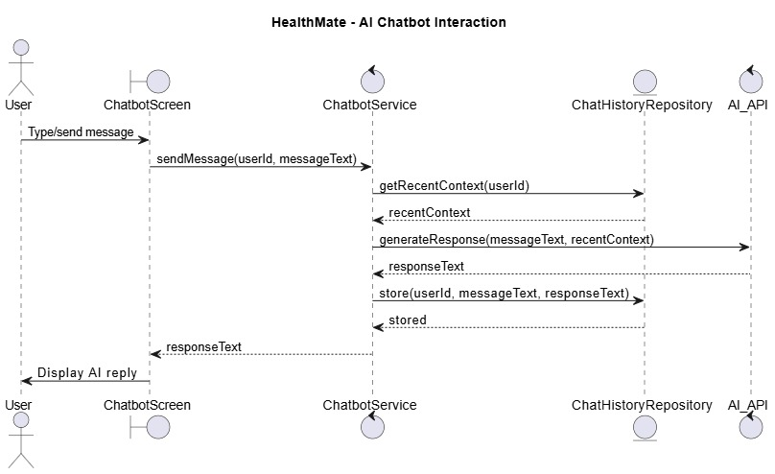
Figure 4.3.3.1: Sequence Diagram for AI Chatbot Interaction

Sequence Diagram for Health Data Collection & Dashboard Display
This sequence diagram depicts a way in which the health data is gathered by the sensors on the device, processed by the system, and saved on Firebase. The system takes the real-time data like steps and calories, corrects it and aligns it to the cloud database. This data is then stored and can be accessed later and shown on the user dashboard in a structured format. In this diagram, the device sensors, application logic, and cloud storage are emphasized, which allows the flow of data and real-time changes. This includes real-time data such as steps and calories. The data is then sent from the sensors to the system. The system logic is then responsible for processing the information. The data is then processed to structure it. Next, the data is ready to be stored. The cloud database used to store the information is Firebase. The data is sent to Firebase in its corrected form. The information is stored in the cloud database. This information is available when needed. As needed, it retrieves the data from Firebase. The data is transmitted back to the app. The app logic processes the data for presentation. Data is then displayed in the user dashboard. The entire stream ensures a seamless flow from data collection to presentation. These parts play their respective roles. The sensors are designed to collect current values.
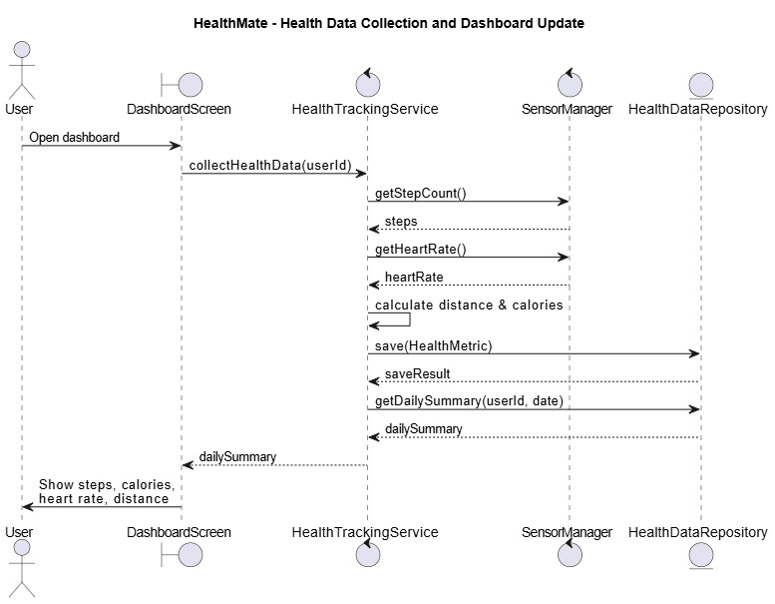
Figure 4.3.4.1: Sequence Diagram for Health Data Collection & Dashboard Display

Sequence Diagram for Emergency SOS
This sequence diagram is the description of the procedure of dispatching an emergency notification with the help of the SOS feature. Upon pressing the SOS button, the system will instantly send an alert and will notify emergency contacts predefined by the user. The system is fast to work with the request so that there is fast communication. This diagram identifies the interplay between the user interface, system processing and communication services, which makes them dependable and swift in responding to critical scenarios. The workflow is triggered by the user pressing the SOS button on the user interface. The system immediately picks up the request for action. It acknowledges the request as an emergency call. It then proceeds to generate the alert. The alert is ready to be sent to emergency contacts. It fetches the emergency contacts from the user's profile. The contacts are included in the alert. The system guarantees that all contacts receive the alert. The system uses communication services for the emergency alert. The alert is sent rapidly to arrive in a timely manner. This request is given priority over normal processing. The user interface shows the SOS action is in progress. The system proceeds until the SOS is sent. The individual steps are run in sequence. The sequence guarantees no steps are missed. The notification is a key operation.
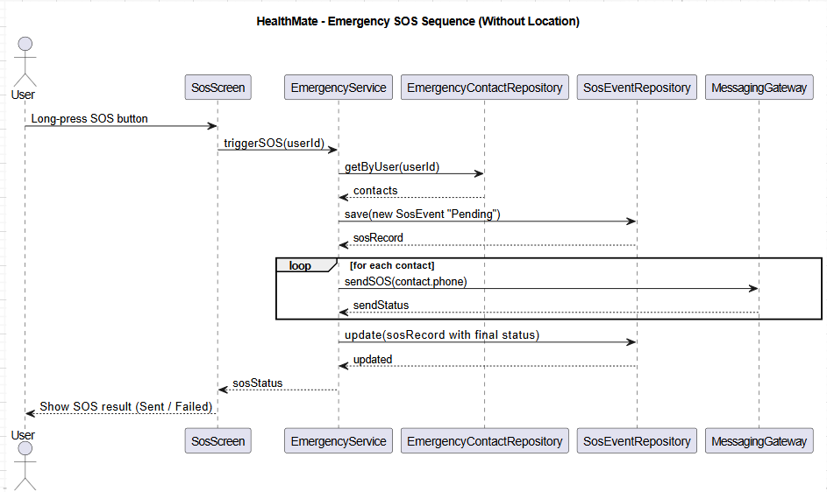
Figure 4.3.5.1: Sequence Diagram for Emergency SOS

State Transition Diagram
The state transition diagram shows the different states of the HealthMate system and its transition to the different states depending on the actions of the user. As an illustration, after a successful authentication, the system can transition to the dashboard, and then to other modules, e.g., health tracking or chatbot interaction. It also symbolizes event transitions like events like a logout or an error. This diagram is useful in knowing how to control the behavior of a system, the flow of control, and how the application will behave in various circumstances.

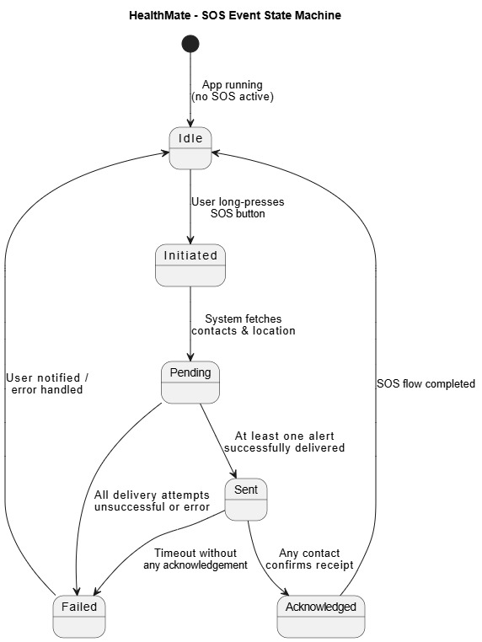
Figure 4.3.6.1: State Transition Diagram

Data Flow Diagram
DFD Level 0: Context Diagram
The Level 0 Data Flow Diagram (DFD) or context diagram is a high-level graphical representation of the HealthMate system that depicts the system as a single process. It indicates the interaction of external objects like the user, Firebase and APIs with the system. The diagram is concerned with the data flows between these entities and the system, including user data as inputs and responses and analytics as outputs. It gives a clear boundary of systems and external interactions. The Level 0 Data Flow Diagram offers a high-level view of the HealthMate system as a single process. It depicts the interaction with external entities without showing details of the system. The user is depicted as the main source of data to the system. Firebase is represented as an external data entity. APIs are also represented as external sources. This diagram is centered around data flows between these external services and the system. Inputs from the user are fed into the main process of HealthMate. The system processes the inputs and produces outputs. Outputs are fed back to the user via data flows. Analytics are produced as part of the system output. Firebase enables the sharing of stored information or data. APIs help to manage data operations. The diagram clearly defines the boundary between the system and outside. Separates the system's internal from its external environment. Arrows show the flow of data between parts. Arrows are labeled to indicate what data is flowing. The diagram is simple and straightforward. It avoids internal system complexity. It is interaction, not structure, focused. The diagram shows a comprehensive picture of system interaction.
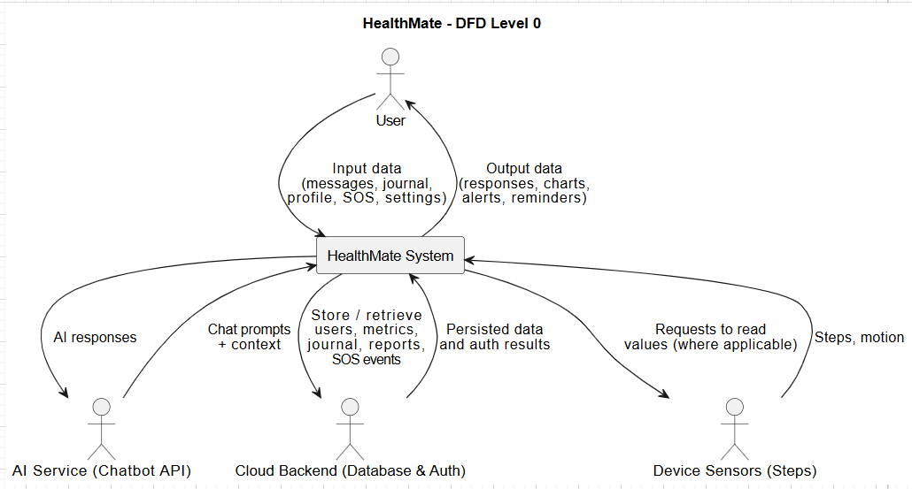
Figure 4.3.7.1: DFD Level 0 Context Diagram
DFD Level 1: Core Processes
The Level 1 DFD further breaks down the system into greater detail by subdivision into core processes of user authentication, health tracking, chatbot interaction, and storage of data. It depicts the data flow between the internal processes and data repositories, such as Firebase. The diagram also illustrates the interaction of various modules with each other to carry out the system operations. This assists in grasping how the internal workflow and the entire system functions in a systematic way. The first level (level 1) of the Data Flow Diagram gives a breakdown of the HealthMate system with its internal processes. These are represented as distinct processes in the system. User authentication is shown as one of the key processes for access management. The health tracking process is indicated as another process for monitoring health-related data. Chatbot is shown as a process to represent user-system interaction. The diagram shows how data is stored in processes such as Firebase. The diagram illustrates the flow of data between the processes. User inputs are fed into the appropriate processes. Data is processed as per the process assigned and then transmitted. Firebase is used to centrally store the processed data. Data flow paths clearly show the interaction of the modules. These paths indicate the information flow between modules.

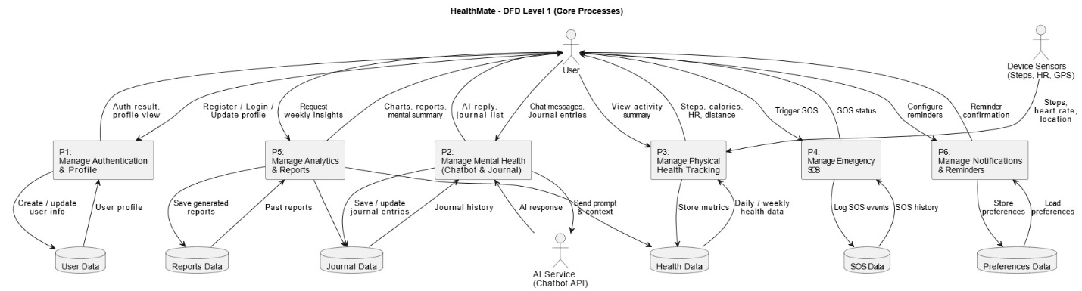
Figure 4.3.7.2: DFD Level 1 Core Processes

Chapter 5
Implementation

Implementation
In this chapter, the authors provide the practical implementation of the HealthMate system in reference to the architectural and UML models provided in the prior chapters. Its implementation is based on a modular, and layered design that separates the user interface and application logic, data management, as well as external services including Artificial Intelligence and cloud backend. The Flutter framework was used to create HealthMate in Dart programming language to provide the application with implementation on Android. Firebase services were added to deal with user authentication, cloud database storage (Firestore) and synchronization of real-time data. The implementation of the AI mental health chatbot was based on Gemini APIs, which made it possible to engage in intelligent dialogue with Natural Language Processing (NLP).Implementation of the system can be partitioned into autonomous service modules which include authentication, health tracking, chatbot service, analytics, SOS management, and security control. This will ensure that each of the modules has a channel of communication to the central data layer, but has a modular independence to ensure maximum scalability and maintainability.
HealthMate's implementation process involves a systemic development of all modules in accordance with the system architecture. The user interface layer is the visual layer that deals with all the user interactions and displays. It interacts with the application logic layer for user input. The application logic layer is the central processing unit of the system. It communicates with various services including authentication, health monitoring, chatbot, analytics, SOS (an alarm function) and security control. This layer processes all user requests. Firebase is used for authentication and security. A cloud database Firestore is integrated to store and retrieve user data. Data is synchronized in real time to provide immediate updates. The AI chatbot is integrated with Gemini APIs for Natural Language Processing of user questions. The health monitoring feature is connected to the system inputs to receive related data. SOS control is developed to manage SOS queries. Security control provides management according to specified security rules. Modularity enables independent operation of each service with the main system. This facilitates clarity in implementation. The architecture facilitates interaction between services. Modules work together to provide the desired functionality. The implementation provides a structured approach. In summary, the implementation is consistent with the design.
HealthMate's development focuses on the independence of modules, but also on the integration of the system. Each of the system services is developed as an independent service. Firebase is used for authentication to securely identify users. Successful authentication allows access to other system functionalities. Health data module handles user inputs related to health and feeds them into the system. Chatbot service uses Gemini APIs to provide intelligent answers to user questions. Analytics module is used to analyze user data and provide insights. SOS handling module prioritizes emergency processing. Security control module is used to validate security rules. Centralized data management is ensured via Firebase services. Data storage and synchronization is supported by the cloud backend. Modules communicate with each other through the central application logic layer. The layer is used by the modules to share the necessary data. The system guarantees data exchange in an orderly fashion. The implementation involves proper separation of concerns in modules. This aids in keeping the system well-organized. The design allows for straightforward maintenance and updates to components. Each service can be updated without impacting other services. This method ensures system stability.

Algorithm
Here, the major modules logic of natural language form has been described. The core functionalities are performed which is explained through the description of the system algorithms in a conceptual manner. The algorithms for the system are meant to describe the sequence of operations performed in the HealthMate system. Each module has a sequence of operations to execute its functions. These processes are explained using the natural language form. This allows us to know how each component works when it is run. The basic functions are explained without the inclusion of programming syntaxes. The inputs given by the user are viewed as the beginning of the algorithm. They are processed as per the rules specified in the modules. The operations are then executed according to the type of input. Outputs are produced following the processing stages. Control is managed in an orderly fashion. Different algorithms are used to describe different features of the system. The description guarantees clarity of system operation. The steps and procedures are presented in logical order. Where needed, decisions are incorporated in the system. The system ensures that the operations are performed correctly. Outputs are generated from inputs. The algorithms represent operations performed by system modules. This assists in understanding system operations. The emphasis is on visualizing operations. In summary, the algorithms represent the logical working of the system.

User Authentication Logic
The authentication process is initiated when the user chooses between registration and the login. To the novice users, the system verifies the input details and makes an account with Firebase Authentication. In the case of existing users, credentials are authenticated with stored authentication records. After successful verification, the user profile information is extracted from the system and redirects the user to the dashboard. In case of the failure of authentication, a proper error message is shown. This will guarantee the safe access control and safety of user information. The authentication process verifies users before they can use system functionality. It all starts with the user interface accepting input. The input is then sent for authentication depending on the option chosen. Sign up includes verification of user data before creating an account. Firebase Authentication is used to create new accounts. Existing users have their login information verified against the database. This is used to decide if the user should be granted access. If this check is successful, the system can identify the user. It then fetches the user profile information. This data is used to tailor the user's experience. The system guarantees only the right users get to the dashboard. In case of failure, the user cannot proceed. The system ensures tight control of access. There is an order to the checks. It manages both new and existing user accounts. The system deals with authentication results as soon as possible. The process provides a uniform user request process.

Health Tracking Logic
The health tracking module works based on the available smartphone sensors of the device, which is accelerator. The system regularly observes the number of steps made, calories burnt estimation and heart rate. The data is then collected, processed and normalized and temporarily stored in the area. With the availability of internet connectivity, this data is synchronized with the cloud database by the system. The health monitoring component of the system works by continuously collecting sensor values from the device. The device's accelerator sensor is used to count the number of steps the user takes. Data from the heart rate sensor is included if the device provides this feature. The sensor data is sampled periodically to keep the system up-to-date. Data points are fed to the processing step for interpretation. During processing, sensor values are properly sorted. The processed data is then normalized. The data is temporarily stored while being synchronized. It allows for temporary data storage of the tracking information. The system monitors for network connections. When internet is available, data is synchronized with the cloud database. Data records are then sent to the cloud. This keeps health data up-to-date. Data synchronization keeps the device and cloud in sync. This ensures no data is lost in the process. The update represents the most recent activity of the user. The module has a sequence of steps for data collection and storage. The data from the sensors is processed in a systematic manner.

AI Chatbot Interaction Logic
The AI chatbot module enables the users to type or voice their input in terms of emotional or general health issues. The system passes the message of the user to the Gemini API to be processed. The API processes the input with the help of the NLP technology and produces a response based on context. The answer is then presented to the user in the chat interface. The history of conversation is saved in a safe location to preserve continuity in context and also to protect privacy. The AI chatbot system handles user interactions in a series of steps. This involves receiving user messages in the chat interface either in text or by voice. The system receives these messages. The message is then processed by the Gemini API. The API uses Natural Language Processing to understand the message. Context is used to create a response. An output is generated based on the user's message. Once processed, the response is sent back to the system. The chat system then receives this response for display. The user interface provides the response through the chat. The processes for each interaction are defined. The system maintains a message order. This enables context to be maintained.. The next message is processed with the previous context. The chatbot module ensures continuous processing. The cycle facilitates interaction with user and API. Message is delivered to complete the interaction.

Emergency SOS Logic
When the user presses emergency button, the SOS functionality is activated. The system looks up pre-established emergency contacts. The necessary information is sent to the selected contacts in the form of an alert message. In case of failure to deliver, the user is informed. The SOS function is initiated as soon as the emergency button is triggered. It identifies the request as an urgent one. Next it fetches the list of pre-set emergency contacts. The contacts are maintained in the system for emergency needs. Afterwards, the system sends the alert message. This message includes the information to be sent to the contacts. The message is formatted properly by the system. The message is sent to the contact, using the communication services. The message is transmitted in a serial fashion. The message is delivered to each contact through the system. If the delivery is unsuccessful, failure is detected. The issue is identified during the delivery process. It then provides a response to the user. The user is notified of the failure. The emergency process is controlled by the system. The procedure is terminated once all delivery and notification attempts are made.

Weekly Report Logic
The analytics module creates weekly reports through analysis of health metrics. The level of activity of the last seven days are analyzed in the system. In relation to this analysis, it generates report so that users can know their physical health and development. These reports aid in self-evaluation and promote regular good health. Altogether, HealthMate implementation incorporates mobile sensor technology, AI-based conversation support, and data storage on the cloud as well as modular service architecture. The orderly execution assures credible performance, safe operations of sensitive information, ability to expand later on to improve and meet the design goals of the system. It is designed to assess the activity level over the past seven days. It analyses the data to detect activity patterns. All the metrics are taken into account in the analysis. The data is organized prior to producing output. The system guarantees that only pertinent health information is considered. This report is used to produce a report. This report shows the status of physical health over time. It includes information on variations in activity. The report is available within the system. This is accessible via the user interface. The analysis helps to understand personal health. It ensures computations are made in a systematic way. Each report is based on the past seven days of data. The module is accurate in calculating health metrics. Data is used to generate reports. It presents the outcome in an understandable manner. The process of analytics is based on the system structure. The results aid in raising user awareness.

External APIs
The table below elaborates the external APIs employed in the HealthMate project, their functionality, and how the APIs are applied in the system architecture.
Table 7: API specifications in the project
Name of API | Description of API | Purpose of Usage | Function/Class in which it is used
Firebase Authentication API | Cloud-based authentication service provided by Firebase for secure user login and registration. | To manage user registration, login, password recovery, and secure session handling. | AuthService, UserManagementModule
Firebase Firestore API | NoSQL cloud database service for real-time data storage and synchronization. | To store user profiles, health metrics, journal entries, SOS logs, and analytics data. | HealthTrackingService, JournalService, AnalyticsService
Firebase Cloud Messaging (FCM) | Messaging service for sending push notifications to mobile devices. | To send reminders and notifications such as water intake, sleep reminders. | NotificationService
Gemini API (Flash Model 1.5) | AI-based Natural Language Processing API for conversational interaction. | To generate intelligent chatbot responses for mental health and wellness guidance. | ChatbotService
Device Sensor APIs (Android) | Built-in mobile device APIs for accessing accelerometer. | To collect real-time physical activity data such as steps. | HealthTrackingService

User Interface
HealthMate user interface is developed based on the principles of simplicity, consistency, accessibility and clarity. The interface makes the application user friendly such that a user of various age groups can navigate the application easily and without any complicated nature. The design is structured as a modular one with each of the major features displayed in clearly labeled screens with easy-to-follow elements of navigation. Flutter was used in the creation of the UI to make it responsive to the screen sizes and operating system (Android). The application's user interface has an ordered structure that facilitates its use. The information on each screen is structured to make it easy to understand. The user controls are positioned in a manner that facilitates easy navigation. The modular layout helps to divide each major feature into sections. This makes it easier to locate the necessary features. The design of the interface is consistent throughout different screens. This helps users easily recognize features across the app. Ease of understanding is kept in mind. Flutter helps to provide consistent look and feel across supported devices. The responsiveness of the user interface to screen sizes is also important. Visual clarity is not affected by device differences. The visual design doesn't overwhelm the user. Key elements on the screen are quickly identified. The user interface is always easy to navigate. Data is presented in an organized manner. It provides consistent responses to various user actions. UI design allows for easy access to key features. In short, the interface is user-friendly with a consistent and structured design.
- Splash Screen: Shows the animation and the first thing it does is to start the services in the background including authentication and database connectivity and redirects the user towards the login or dashboard page. The system starts up with an animation displayed on a screen. The animation is displayed while the system starts its services. Services are started automatically in the background. Services related to authentication are also part of the initialization. It also initializes the database connection. These services are made available for user requests. With the services in place, the system then checks the user state. This includes whether the user is logged in or not. The system then decides which screen to display. If the user is not authenticated the system selects the login screen. If the user is authenticated, the dashboard is selected. This is managed by the system. The animation will be played until the decision is made. Once this is complete, the redirection occurs. The user is redirected to the page that the system deems suitable. This guarantees services are primed for use. There is a seamless start-up to operation. The process guarantees that initialization and redirection are sequential.

- Registration and Log-in Screen: Provides the ability to register a new account or log in safely by email and password. It has a password recovery option as well. This module facilitates registration and login using email and password. Users can register themselves with certain credentials. The user's details are validated on registration. If verification is successful, the account is successfully created. Users can login to the system using their credentials. It verifies the entered email and password. The user is only allowed access if the details are correct. It helps to manage user access. Protection is provided during registration and login. The password recovery feature is used by users who forget their password. It enables users to recover their account via a recovery process. Recovery requests are managed efficiently. They are evaluated based on the information presented. The system verifies before enabling account recovery. The module allows only legitimate users to regain access. Authentication tasks take place in a secure flow. The system is consistent in checking user identity. It keeps logging in and registration linked but distinct. The workflow enables secure user access.

- Dashboard Screen: The first screen upon a login. It presents a summary of metrics related to health on a daily basis and has easy access to key modules, including Chatbot, Activity Tracking, Journal, SOS, games and music. It displays important health values for the current day. These are displayed appropriately for easy comprehension. It is also designed to provide easy access to all modules. A link to 3D model based training is also provided on the dashboard. The user can access the Chatbot feature. Activity Tracking is also one of the options. The Journal can be accessed via the dashboard. SOS can be accessed for emergencies. Games are included as an interactive element in the interface. A music player is also available. Modules are presented as a form. This makes it easy for users to locate features. The design is intuitive for easy use. The dashboard provides an overview of main features. Data is updated daily. This will help them track progress. The display is clear and visually true. The display is the focal point for the app.

- AI Chatbot Screen: Offers a chat interface to the users to communicate with the AI assistant. It facilitates text interactive and optional voice interaction. The users can send their questions via text input. The text in the messages is used for processing and generating responses. It also allows for optional voice input for added convenience. Speech is converted into a suitable format. The user's message is passed to the AI assistant. The interaction is processed in a series of messages. The user input is correctly communicated to the assistant. The AI system processes the user request. It generates a reply to the input. The reply is passed back to the chat interface. The response is presented in a user-friendly way. The messages are presented in a structured format. The dialogue is an ongoing conversation. The user can see past messages. The chat environment enables seamless communication between user and AI. Users can type or use voice commands. The system displays interaction between user and assistant.

- Activity and Tracking Screen.: Shows real-time data on physical activity such as steps, calories. Charts are used to present data and make it easy to monitor. The physical activity screen displays information regarding the user's activity in real-time. It logs health metrics like step count, calories burned. The data is retrieved from the system and displayed in a structured way. The data is updated in real-time for each indicator. The display is designed to allow users to see how their activity has changed during the course of the day. The information is presented visually in charts. The charts aid in the interpretation of physical activity. Information is presented in a clear way. Multiple health indicators can be viewed on a single screen. The system emphasizes on information presentation. Data is continuously sourced in real time. The values are filtered before they are shown. This ensures that the metrics displayed are accurate. The system displays health data in an organized manner. Users can easily monitor their improvement. Trends of activity are interactively displayed in the charts. All metrics are distinct for easy understanding. The display allows users to track activity on-the-go. The user interface is simple and efficient.

- Journal Screen: Enables users to create, edit and organize journal entries per day with optional mood tagging to track their moods. The journal module enables users to keep daily entries. Users can add and save their entries for later use. Users can also edit their entries as needed. When editing, changes are saved for future reference. Journal entries are stored as per the date of respective entries. This aids in keeping a daily record. Journal entries are maintained in an organized manner. Any previous entry can be clicked for viewing the details. Entries are displayed in an easy-to-read format. Entries can be tagged with a mood if desired. This can be used to link content to emotions. Text and mood details are recorded. Journal entries are associated with dates. This allows users to monitor their moods over time. The layout facilitates browsing through the days. The system guarantees that any changes to entries are recorded. Users can always view entries in the journal module. The module ensures that the journal information is clear.

- Weekly Report Screen and analytics: Displays graphical report of physical health trends, which allows users to analyze the progress over time. The graphical report function displays trends in health information graphically. It gathers physical health data over time. It will then sort the data to produce the graph. Each trend is represented in a tabular format in the report. A user can track fluctuations in his/her health over time. The visualizations are based on analyzed health data. This makes it easy to compare time intervals. The system guarantees that the information is based on health metrics. The graphics represent different aspects of exercise. It is presented in a way that is easy to understand. It's easy for users to see the changes in the report. There is a consistency to the way data is shown. Patterns are displayed in a continuous way. The report is primarily concerned with showing progress trends. Information is transformed into a visual format. Updates are reflected within the pattern. The solution is accurate in presenting health data. The trend graph aids in observing long-term trends. The trends allow users to assess their progress.

- Emergency SOS Screen: The product will have an emergency trigger button and predefined contacts to provide emergency alert notification in case of emergency. The emergency button is supposed to initiate an alert when the user presses the button. The system immediately detects this as an emergency call. The system then proceeds with the emergency activation. The contacts stored in the system are accessed. These are determined according to the user's configuration. An emergency alert message is generated by the system. The alert is formatted to convey an emergency. Upon preparation, the message is transmitted to the contacts. The message is guaranteed to reach all the contacts. The alert is delivered via a specified mechanism. All contacts are part of the system flow for sending the alert. The delivery process is tracked by the system. Sending confirmation is verified in the system flow. Upon successful sending of the alert, the process is completed. The emergency request takes precedence over other processes. The trigger action starts the alert process. The workflow steps follow a predetermined order. The messaging process is centered on timeliness. After the messages have been sent, the emergency alert process is complete.

- 3D Model Based Fitness Screen: Displays the 3D model on the screen. The 3D model is displayed on the screen for interaction. Users can see the model from the display. The screen is set up to display the model. Users can view how the model looks on the display. The model is presented in a suitable format. The screen is used to facilitate user practice. Users can use the displayed information to change their health. The user interface displays the model while in use. The screen is the primary interface for the 3D model. The model is accessible while using this feature. Users can concentrate on studying the model. The model is presented clearly to users. The model's view is not disturbed. The model can be viewed as often as desired. The feature is intended for practice. The model is positioned in the center of the page.

- Profile and Settings Screen: Allows users to make changes to personal information and enable the app lock features. The settings module offers a space for users to adjust various settings within the app. Personal information settings are available for users to edit their information. The application guarantees that any changes are handled in a controlled manner. These preferences can be used to manage information received. There is also security settings to support user control over security. The interface allows users to view and manage security settings. App locking is also offered in this section. Users can secure the app using this function. The settings are presented in a coherent manner. Users can easily find the settings. The system processes updates to the settings appropriately. There are mechanisms to handle updates to settings. The settings verify user inputs before saving them. The settings module is organized for easy navigation. The various sections are clearly divided. Options are presented in a consistent manner. Setting options can be accessed easily. It keeps all settings in control. In summary, the settings module offers organized settings management.
All in all, the user interfaces provides ease of navigation, presentation of information, and security of interaction in the HealthMate application. The user interface is aimed at providing an organised interaction in HealthMate. The structure of the user interface enables easy navigation through the system. Data is presented in a clear manner for easy comprehension. Content on each screen is presented in a systematic way. The user interface is consistent throughout the system. Interaction security is maintained while the user interacts with the system. The interface enables the user to navigate to other functions. The system aims to simplify the usage. Data is displayed in a readable manner. Users can easily locate necessary options. The application behaves in a stable manner. The application processes user interactions via the interface. The interface elements are well defined. It facilitates efficient use of the application features. It allows users to interact with the system with as little confusion as possible. The user interface is consistent. It provides a predictable user experience. Interactions are protected by security measures. Information is displayed in a neat and structured way. In all, the interface facilitates user-friendly, clear and secure interaction with the application.

Home Dashboard Screen for HealthMate
The HealthMate application has the Home Dashboard screen as the primary interface. It gives the users a summary of their daily health activities such as steps, calories, and mood status. The screen is also easily navigable with the ability to access key features like chatbot, health tracking, journal, and emergency SOS, all of which are easily accessible.

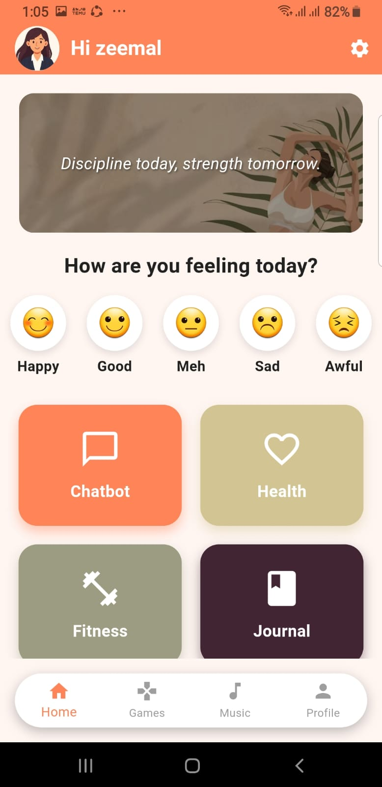
Figure 5.3.1: Home Dashboard Screen for HealthMate

Mood Tracking Screen for HealthMate
Mood Tracking screen enables users to journalize and track their emotional conditions every day. Users have a choice of their mood or can type in what they feel and this is saved and evaluated to provide insights in the long run. The given feature is useful in recognizing emotional patterns and assists in managing mental health.

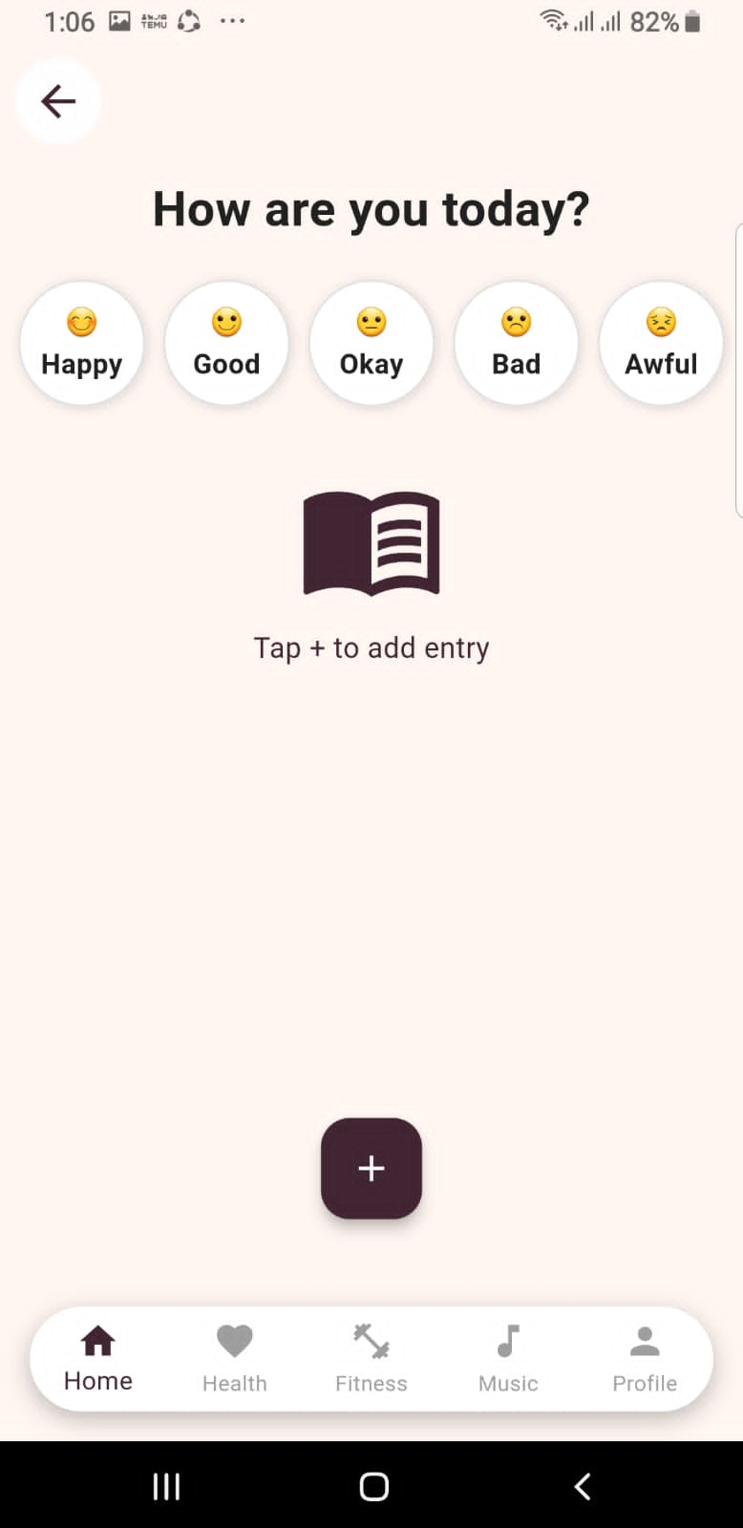
Figure 5.3.2: Mood Tracking for HealthMate

Health Tracking Screen for HealthMate
The Health Tracking screen shows in-depth data about the physical activities of the user that include the number of steps taken, the number of calories burnt, and other health indicators. This information is gathered using sensors on the device and displayed in a structured format to enable users to monitor their fitness level.

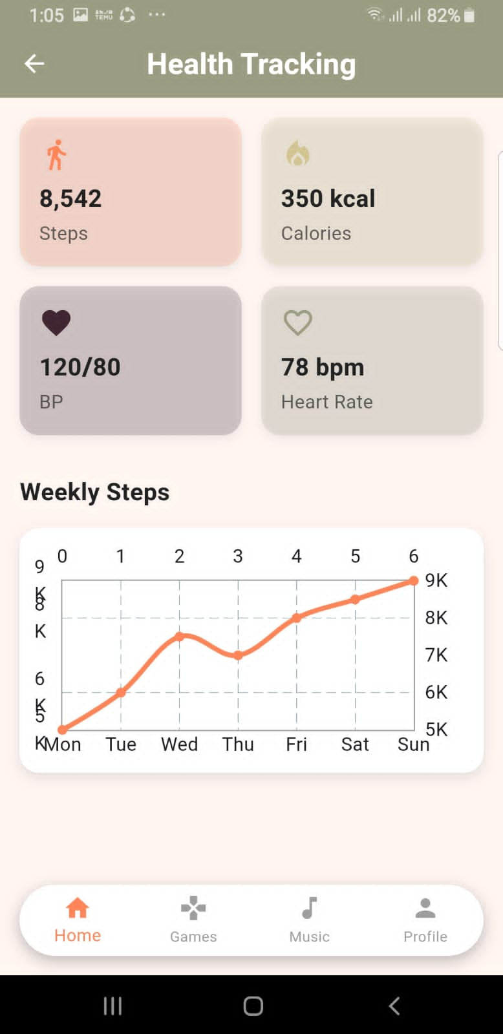
Figure 5.3.3: Health Tracking Screen for HealthMate

Music Player Screen for HealthMate
Music Player screen gives users access to the relaxing and motivational audio files. It is created with the purpose of mental relaxation and stress reduction as it enables users to listen to relaxing music during the application use.

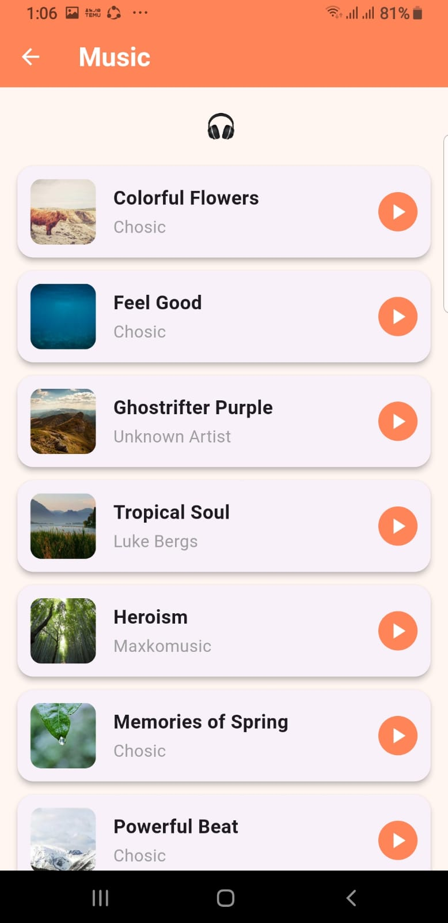
Figure 5.3.4: Music Player Screen for HealthMate

Game Selection Screen for HealthMate
The Game Selection screen provides numerous games of relaxation and relieving stress. The simple interactive games allow users to select and play games that increase mental health and interaction. This attribute boosts user experience by integrating entertainment and stress management.

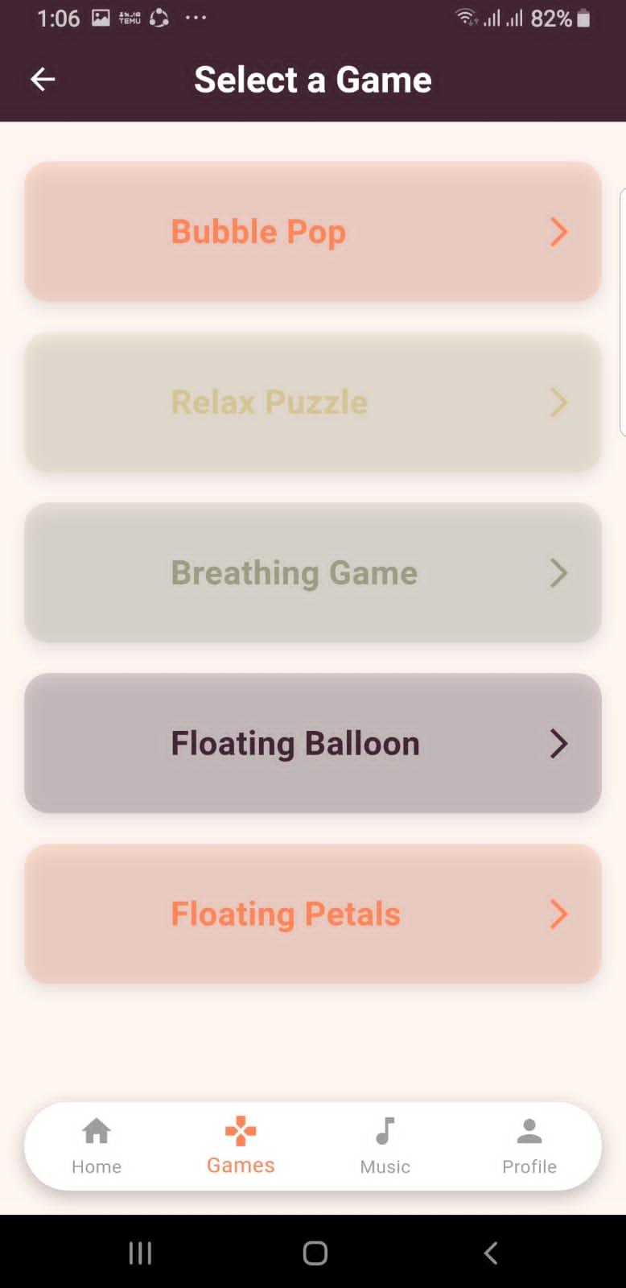
Figure 5.3.5: Game Selection Screen for HealthMate

Chapter 6
Testing and Evaluation

Testing

Manual Testing
Manual testing was also carried out to ensure that every module of HealthMate system is working properly as per the requirements. The testing was done by running of the test cases manually to detect the errors, test the system behavior and checking the overall reliability, before all the testing is done and the deployment is made. During manual testing, we tested the proper operation of individual modules in the HealthMate system. Individual test cases were run to test system behavior. Modules were tested according to their specifications. This required comparing the results against specifications. Testing identified any unexpected behavior. System responses to various conditions were monitored. Any test errors were documented. The reliability of each feature was tested. The tests made sure that modules were behaving properly. The application was tested by running test scripts. This allowed for inconsistencies to be detected. The application was tested again to determine stability. The outcomes of the tests were verified with the expected results. Correctness of the system was verified before deployment. Observation was used for validation. A formal process was followed for each step of testing. The emphasis was on pre-release issues. The system was rigorously tested for correctness.
Table 6.1.1: Manual Testing for HealthMate AI-integrated health and fitness app
Test Case | Expected Result | Actual Result | Pass/Fail
Login with valid email and password | User successfully redirected to Dashboard screen | User redirected to Dashboard successfully | Pass
Login with invalid password | Error message “Invalid Credentials” displayed | Error message displayed correctly | Pass
Register new user with valid details | New account created and redirected to Dashboard | Account created successfully | Pass
Submit registration form with empty fields | Validation error message displayed | Validation message displayed correctly | Pass
Track physical activity with sensors enabled | Steps and calories displayed correctly | Data displayed correctly | Pass
Open activity tracking without sensor access | Sensor error message displayed | Error message shown correctly | Pass
Send message to AI chatbot | AI generates relevant response | AI response displayed correctly | Pass
Chatbot without internet connection | Connection error message displayed | Error message shown correctly | Pass
Create journal entry | Journal saved successfully | Journal stored in database | Pass
View weekly analytics report | Weekly chart displayed | Chart generated correctly | Pass
Trigger SOS with saved contact | Emergency alert sent successfully | SOS alert delivered successfully | Pass
Trigger SOS without saved contact | Warning message displayed | Warning displayed correctly | Pass
Receive scheduled notification | Notification appears at scheduled time | Notification received correctly | Pass
Access 3D fitness mode | 3D model loads on screen | 3D model loaded successfully | Pass
Enable App Lock | App requires PIN authentication | Lock activated successfully | Pass
Mood Detection and Recommendation | Detect Mood | Mood detected successfully | Pass

Unit Testing
Unit testing was conducted to ensure that every single component of the HealthMate system works properly and independently as per the requirements. Every feature was then tested with known input values so that the output is accurate and the error is handled correctly before the system is integrated. Unit testing verified the proper functioning of each module in the HealthMate system independently. Each feature was evaluated individually to verify its functionality. The features were then tested with known inputs. The results were compared with the anticipated outcomes. This assisted in detecting functionality issues. Test cases were run in controlled environment. The responses from the system were observed for correctness. The test cases also tested error handling. Emphasis was placed on testing individual components. The functions were tested individually to prevent interdependencies. It was verified that the individual components worked correctly. Any differences were noted for analysis. The operation of each feature was reviewed. This aided in establishing component level confidence. Repeatability of the tests was checked. Each unit was tested multiple times if necessary. The system exhibited expected behavior in all tests. The results verified correct operation of each unit.
Table 6.2.1: Unit Testing for HealthMate AI-integrated health and fitness app
Test Case ID | Test Case Name | Attributes & Values Tested | Expected Result | Actual Result
UT-01 | User Login (Valid Credentials) | Email: testuser@gmail.com Password: 12345678 | User successfully redirected to Dashboard screen | User redirected to Dashboard successfully
UT-02 | User Login (Invalid Password) | Email: testuser@gmail.com Password: wrong123 | Error message “Invalid Credentials” displayed | Error message displayed correctly
UT-03 | User Registration | Name: Aliha Email: newuser@gmail.com Password: 12345678 | New account created and redirected to Dashboard | Account created successfully
UT-04 | Edit Profile | Updated Name: Aliha Updated Age: 22 | Profile information updated | Profile updated successfully
UT-05 | Health Tracking – Sensors Enabled | Accelerometer: Active | Steps and calories calculated and displayed | Health data displayed correctly
UT-06 | Health Tracking – Sensors Disabled | Sensors: Disabled | Sensor error message displayed | Sensor error message shown
UT-07 | AI Chatbot Response | Input: “I feel stressed” | AI generates supportive and relevant response | AI response generated correctly
UT-08 | Journal Entry Creation | Title: Daily Log Mood: Happy | Journal entry saved successfully | Journal entry stored in database
UT-09 | Emergency SOS Trigger | Emergency Contact: 03001234567 | SOS alert sent to saved contact | SOS alert sent successfully
UT-10 | Weekly Analytics Generation | Last 7 days health data | Weekly report generated with charts | Weekly report displayed correctly
UT-11 | Mood-Based Recommendation | Uploaded facial expression image | Mood detected and songs/movies recommended | Personalized recommendations displayed

Functional Testing
Unit testing was followed by functional testing to make sure that every module of the HealthMate system functions as per the functional requirements. This testing confirms the full functionality behavior on the side of user and also guarantees that the system outputs will be as per expectation. Functional testing is a process which tests the overall behavior of the HealthMate system from the user's point of view. The different modules of the system are tested to ensure that they function as expected. The system is tested against functional requirements. Different user interactions are simulated. The results are compared against anticipated results. This ensures that the system is operating correctly. Testing is done in a real working scenario. The testing helps validate the complete functionality. The responses to user actions are checked. The modules are checked for their coordinated operation. Any discrepancies are noted. The system is checked for correctness of output. All functional flows are verified. User operations are checked. The tests ensure that system functions are executed. All cases are tested under normal circumstances. The behaviour of the system is evaluated.
Table 6.3.1: Functional Testing for HealthMate AI-integrated health and fitness app
No. | Test Case / Test Script | Attributes & Values Tested | Expected Result | Pass/Fail
1 | Login with valid credentials | Email: testuser@gmail.com Password: 12345678 | Dashboard loads with correct navigation and user data | Pass
2 | Login with invalid credentials | Email: testuser@gmail.com Password: wrong123 | Error message “Invalid Credentials” displayed | Pass
3 | Register new user | Name: Sara Email: sara@gmail.com Password: 12345678 | New account created and redirected to Dashboard | Pass
4 | Track physical activity | Sensors enabled (Accelerometer) | Steps, calories, and heart rate displayed correctly | Pass
5 | Access AI chatbot and send message | Input: “I feel anxious” | AI generates appropriate supportive response | Pass
6 | Create and save journal entry | Title: Daily Mood Mood: Happy | Journal entry saved and visible in journal list | Pass
7 | Generate weekly analytics report | Health data for last 7 days | Weekly chart displayed | Pass
8 | Trigger SOS alert | Emergency contact saved | SOS alert sent successfully to saved contact | Pass
9 | Access 3D model based Fitness mode | 3d model displayed | 3D model workout interface loaded successfully | Pass
10 | Enable app lock security | PIN set: 1234 | App requires PIN authentication on reopen | Pass
11 | Access AI Mood-Based Recommendation | Detected mood: Happy | Recommended songs/movies | Pass

Integration Testing
Integration testing was also carried out to test the modules of the HealthMate system that interact with each other or not. This testing confirms that there is correct communication between user interface, backend services, AI integration, database and device sensors. The integration testing process aims to test the communication between the HealthMate system's modules. Modules are integrated with others to track their interaction. User interfaces are combined with services to check data passing. AI is tested to ensure appropriate response from system. Testing is also done to ensure correct data exchange between components. The system also involves sensors from devices to check data flow into the system. Testing guarantees that all modules work together. Data transmission among modules is observed in various tests. Any communication error is detected. The system behavior is evaluated with multiple modules. The interactions are tested in isolation. The interaction of the modules is checked. Data exchanges among modules are tracked. The interaction of the system is tested for service integration. The synchronization between components is tested. The connection ensures communication is not lost. Interconnected processes are tested for proper execution. The test ensures seamless interaction. The testing demonstrates system-wide integration of modules.
Table 6.4.1: Integration Testing for HealthMate AI-integrated health and fitness app
No. | Test Case / Test Script | Attributes & Values Tested | Expected Result | Result
1 | Login and load dashboard | Valid Email & Password | Successful login and dashboard loads with user data | Pass
2 | Track activity and sync to cloud | Sensors active, Internet enabled | Health data collected and synchronized to Firebase database | Pass
3 | Chat with AI and store conversation | Valid message input, Internet enabled | AI response displayed and conversation saved in database | Pass
4 | Trigger SOS with GPS enabled | Emergency contact saved, Location enabled | SOS alert sent with location details | Pass
5 | Generate analytics from stored data | Last 7 days health data available | Weekly analytics report generated correctly | Pass
6 | Update profile and reflect changes on dashboard | Updated Name/Details | Updated profile information displayed on dashboard | Pass
7 | Enable app lock and reopen application | PIN set (e.g., 1234) | App prompts for PIN before accessing dashboard | Pass
8 | Create journal entry and view in analytics | Journal entry saved with mood tag | Journal reflected in weekly mental report | Pass

Chapter 7
Conclusion and Future Work

Conclusion and Future Work

Conclusion
The successful design and development of the HealthMate -AI Integrated Health and Fitness App- was done to offer a complex digital solution to allow one to manage both physical and mental health. The project was a solution to the chosen issue of disjointed health applications as it combined real-time physical activity tracking, AI-based mental health support, journaling, emergency SOS capabilities, analytics, and motivational functionalities into one secure platform.
It deployed the system on the Flutter platform of cross-platform mobile development, Firebase of authentication and cloud database storage, and Gemini APIs of intelligent chatbot communication. Modular development, scalability and maintainability of the system were guaranteed through the application of principles of Agile methodology and Object-Oriented Design. The functionality, integration and system performance were tested both manually and using automation.
Generally, HealthMate shows how Software engineering, integration of artificial intelligence, mobile sensor technology, and cloud computing can be successfully used to create a secure, user-friendly, and scalable digital wellness platform.
The design and development of HealthMate involved the integration of different system components. The system was implemented based on the system design. Functionalities related to physical and mental health were consolidated into one platform. The system architecture facilitated seamless integration of system modules. Flutter was employed to enable cross-platform mobile app development. Firebase was used for authentication and data storage. Gemini APIs were leveraged to support intelligent chatbot conversations. The layered architecture enabled independent development of system components. Organized system structure with Object-Oriented Design principles. Development was structured by the Agile process. Performance of the system was kept in mind. Developed modules were checked for correct functioning. Integration of components was controlled. System was tested to ensure its operation under various circumstances. Manual testing was performed. The system was tested for proper functioning of features. Care was taken to ensure correct modules interaction. The resulting application has integrated use of technologies. The development led to an integrated digital system.

Future Work
This part presents possible improvements that can be made to make HealthMate system more functional, scalable and intelligent in the future.
1. Wearable Interconnectivity
Future editions of HealthMate can be connected to wearable products like smartwatches and fitness bracelets to record more precise real-time health data, such as heart-rate variability, sleep habits, and oxygen levels.
The machine learning models may be integrated into the user behavior analysis, journal patterns, and trends of activities to forecast mood swings and give proactive mental health recommendations.
As HealthMate was developed, future versions can further improve the integration with wearable devices for health tracking. These can supply continuous data to better understand user health. This data can include heart rate variability, sleep patterns and oxygen saturation as mentioned above. This information can be incorporated into the health monitoring system. Machine learning algorithms can be used to study user behavior. Users' journal patterns can also be considered. Temporal patterns can be used to learn user habits. Patterns can be discerned from data collected over time. Analysis can be used to make mood fluctuations predictions. Advice can be given on mental health. Structured data will be used for results. Data will be analyzed from user inputs. Wearable data integration will aid understanding. Movement will be tracked with real-time data. Journal will help pattern matching. The system will continue to focus on user data interpretation. Further releases will add to analysis features.
3. Multi-Language Support
The application can be improved by adding multi-language chatbot support and structure it so that it is more accessible and usable by a wider audience. The enhancement is related to the chatbot feature of the app. Language support enables the chatbot to speak multiple languages. This makes the system accessible to more users. The chatbot's structure can be modified to accommodate language differences. The chatbot will understand user input in the preferred language. The chatbot will respond in the user's language. This will maintain consistency in communication. The system will handle language selection when interacting with the chatbot. The user interface will use the selected language. Users will communicate seamlessly with the chatbot. The process will still be based on user input and chatbot response. The chatbot will continue to perform its role while being multilingual. The same processing steps will be involved in each interaction. The language support will be added to chatbot functionality. This feature will not alter the core functionality of the chatbot. It will only enhance the communication. The aim will be to enhance system usage through language support. The system interaction will be the same.
4. Doctor Consultation and Telemedicine
Connecting with qualified medical practitioners via in-app consultation services can also make the features accessible to the user when they need professional medical advice. The online medical consultation feature allows users to connect with medical experts for expert advice. This provides a means of users directly accessing medical professionals. The app allows users to ask for advice based on their symptoms. The system enables structured interaction between the two parties. Users can seek medical advice and practitioners will answer their questions. The conversation is kept within the app. Patients can express their concerns to the doctor. Consultations are processed in a structured manner. The system offers a medium of health information. Professional assistance is available if necessary. Users can consult in an easy process. Users can receive medical advice via the same app. The service helps users get in touch with health professionals. e consultation process is standardised. The interface facilitates interaction between users and practitioners. System facilitates structured communication. The service provides better access to medical advice.

5. Individual AI Workout and Meal Planning
Additional future additions can be adaptable recommendation systems where a user receives a tailored workout plan and dietary recommendations based on the long-term analysis of user data. The dynamic recommendation system is targeted towards offering customized workout plans. The workout plans are created using historical data. It assesses the user's health and activity data. It also makes dietary suggestions based on this analysis. This is in line with historical data. The system guarantees that recommendations are trend-based. Data is crucial for customized recommendations. The system takes into account long-term data. The system adapts exercise plans based on the information. Food recommendations are paired with user activities. The system is consistent in producing recommendations. Recommendations are based on aggregate data. Personalization will be based on long-term use. It guarantees that the suggestions are tailored to the user. Planning suggestions are based on data insights. The system involves ongoing processing of data. The process results in recommendations for the user. It provides personalized recommendations based on user information.

6. Modern Pre-Judicial Analytics Dashboard
It is possible to extend the system with predictive analytics, which predict possible health risks and give preventive suggestions using the trends of data. The predictive analytics extension is concerned with the analysis of trends in the health data of the system. It explores patterns of user data collected in the past. These are then used to detect potential future health challenges. This data is used to produce predictions about problems. The results are based on changes in user health data. These are used to generate preventive recommendations. The system guarantees that suggestions are derived from trend analysis. Each prediction is associated with a trend analysis. Attention is given to the analysis of long-term trends. Data trend changes are tracked. Predictions are based on structured data. The process guarantees predictions are based on data patterns. Preventive measures are linked to predictions. The system offers insights following information assessment. The aim is to help facilitate early awareness of potential health risks.
7. Improved Security Systems
Fingerprint and facial recognition biological authentication can be implemented to enhance privacy and restricted entry to delicate health and journal records. The biometric authentication system is designed to enhance the security of access to the system. Biometric information like fingerprint is used for identification. Facial recognition is also used for user authentication. These are used to control access to critical areas. This authentication is used to access health and journal information. The user's identity is verified. Biometric data is compared for each authentication attempt. Matching is done in an organized way. Matching permits user access to the app. Failure in authentication does not give access to confidential data. Protected data is accessed through authority checks. Biometric information is only used to authenticate. There is a uniform authentication process in place. Fingerprint and facial input are assessed when logging in. There is a sequence for each verification step. The system controls access to sensitive areas. Data is not accessible until user identity is verified. The whole process enhances privacy and secured access to critical data.
The system will be more intelligent, personalized, and user-friendly in the future and this will make HealthMate a more holistic digital health management solution. The main focus for the future of the system is to improve the overall intelligence of HealthMate. The system will better understand user requirements. Customization will be a critical aspect. It will respond in a way that matches user behavior. This will enhance the user experience for all. User-friendly interaction with the application will be enhanced. Ease of interaction will still be an important design consideration. The system will still allow for ease of navigation. Features will be organized to make them more accessible. Users will have a more intuitive experience. Health management will be more integrated in the system. The app will be designed to centralize aspects of health. It will be easy to use. It will strive to lower the complexity of use. The health information will be clearer. Users will gain better comprehension of health information. They will be empowered to better manage their health. It will continue to focus on comprehensive digital health management. The aim will be to enhance the user experience.
HealthMate development will continue to focus on enhancing user interactions. The system will emphasis on the user's interaction with various functions. The system will provide more intuitive interactions. The application will be designed for maximum user-friendliness. Future enhancements will align to user needs. The app will evolve to meet user needs. Health features will continue to be a focus. The design will enable more organized features. The user will have a more seamless navigation. The interface will seek to minimize navigation costs. Design consistency will still be a priority. The app will have clear information. This will include enhancing user satisfaction through usability. The tool will be developed further based on user experience. All upgrades will improve the system. The design will enable greater user control. HealthMate will continue to target holistic health and wellness. The system will enable equitable engagement of features. The future enhancements will enhance the digital experience.
Future improvements will help HealthMate become a more sophisticated health system. The app will be concerned with the interaction structure. All aspects will work towards a seamless user experience. The system will continue to be user-focused. Health information will be more accessible and comprehensible. The system will still offer structured data presentation. System workflow will be enhanced for better user engagement. But the user interface will continue to be clean and simple. Users will be able to easily manage their tasks. All features will be consistent with usability objectives. Health will still be tracked successfully. Information management will be organised. Complexity will be lessen. Users will have a better interaction. The app will be adaptable to user needs. The system will promote improved health awareness. The design will still focus on integration of health functions. HealthMate will be better at helping users achieve their goals. It will further improve the experience of digital health management. The future of HealthMate system will be geared towards further improvements in its functionality. HealthMate will adapt to user needs. All enhancements will improve ease of use and efficiency. The system will retain its simplicity in all aspects. Emphasis will be placed on user interactions. Access to health information will be facilitated. The system will remain straightforward and simple. Health will continue to be managed in one platform. The design will offer a more comprehensive user experience. All functions will help learn about health. The system will help organize user data. The system will be further enhancing its user interface. Structured design will provide improved experience. The system will deliver complete health care. The system will provide reliable and seamless interaction. HealthMate will evolve as an interconnected system.

References
[1] S. Alsayed, S. K. Assayed, M. Alkhatib, and K. Shaalan, “Impact of Artificial Intelligence Chatbots on Student Well-being and Mental Health: A Systematic Review,” People and Behavior Analysis, vol. 2, no. 2, pp. 1–13, Sep. 2024, https://doi.org/10.31098/pba.v2i2.2411.
[2] Amir Razaghizad et al., “Mobile Health Fitness Interventions,” JACC. Advances, vol. 2, no. 8, pp. 100613–100613, Oct. 2023, https://doi.org/10.1016/j.jacadv.2023.100613.
[3] Amit Bhanushali, “Ensuring Software Quality Through Effective Quality Assurance Testing: Best Practices and Case Studies,” International Journal of Advances in Scientific Research and Engineering, vol. 26, no. iv, p. 1, Oct. 2023, Available: https://www.researchgate.net/publication/375342628_Ensuring_Software_Quality_Through_Effective_Quality_Assurance_Testing_Best_Practices_and_Case_Studies.
[4] R. Dixit and B. Bhushan, “Scrum: An Agile Software Development Process and Metrics,” Journal on Today’s Ideas - Tomorrow’s Technologies, vol. 7, no. 1, Jun. 2019, https://doi.org/10.15415/jotitt.2019.71005.
[5] A. Fabbrizio et al., “Smart Devices for Health and Wellness Applied to Tele-Exercise: An Overview of New Trends and Technologies Such as IoT and AI,” Healthcare, vol. 11, no. 12, p. 1805, Jan. 2023, https://doi.org/10.3390/healthcare11121805.
[6] M. Javeedullah, “Data Privacy and Security in Health Informatics: Ethical and Legal Considerations,” International Journal of Multidisciplinary Sciences and Arts, vol. 4, no. 1, pp. 17–24, May 2025, https://doi.org/10.47709/ijmdsa.v4i1.5777.
[7] F. M. Jones, J. Hamilton, and N. Kargas, “Accessibility and affirmation in counselling: An exploration into neurodivergent clients’ experiences,” Counselling and Psychotherapy Research, vol. 25, no. 1, Jan. 2024, https://doi.org/10.1002/capr.12742.
[8] D. G. K and Supriya Mallad, “Health Mate,” INTERANTIONAL JOURNAL OF SCIENTIFIC RESEARCH IN ENGINEERING AND MANAGEMENT, vol. 09, no. 08, pp. 1–9, Aug. 2025, https://doi.org/10.55041/IJSREM52118.
[9] M. Karol et al., “Sedentary Lifestyle and Academic Stress as Risk Factors for Health Disorders in Young Adults,” Journal of Education, Health and Sport, vol. 87, p. 67461, Jan. 2026, https://doi.org/10.12775/jehs.2026.87.67461.
[10] J. McGuire, “Requirements Analysis for Software Development (Guide) - Pulsion Technology,” Pulsion Technology, Feb. 27, 2024. https://www.pulsion.co.uk/blog/requirements-analysis-for-software-development
[11] H. Mumtaz et al., “Current challenges and potential solutions to the use of digital health technologies in evidence generation: a narrative review,” Frontiers in digital health, vol. 5, no. 5, Sep. 2023, https://doi.org/10.3389/fdgth.2023.1203945.
[12] A. K. Pati and S. K. Paul, “SMARTCHAT: A Real-Time Chat Application With AI-Based Chatbot And Image Generator Using Flutter And Openai,” INTERNATIONAL JOURNAL OF CREATIVE RESEARCH THOUGHTS, vol. 12, no. 4, pp. 2320–2882, Apr. 2024, Available: https://www.researchgate.net/publication/383669225_SMARTCHAT_A_Real-Time_Chat_Application_With_AI-Based_Chatbot_And_Image_Generator_Using_Flutter_And_Openai
[13] J. Sammu, “Human-Computer Interaction (HCI) and Its Influence on User Experience Design,” Dec. 26, 2024. https://www.researchgate.net/publication/390200214_Human-Computer_Interaction_HCI_and_Its_Influence_on_User_Experience_Design.
[14] K. Stemmler, “4 Principles of Object-Oriented Programming | Khalil Stemmler,” Khalilstemmler.com, Apr. 16, 2022. https://khalilstemmler.com/articles/object-oriented/programming/4-principles
[15] H. L. Tong et al., “The use of mobile apps and fitness trackers to promote healthy behaviors during COVID-19: A cross-sectional survey,” PLOS Digital Health, vol. 1, no. 8, Aug. 2022, https://doi.org/10.1371/journal.pdig.0000087.
[16] J. Torous et al., “The evolving field of digital mental health: current evidence and implementation issues for smartphone apps, generative artificial intelligence, and virtual reality,” World Psychiatry, vol. 24, no. 2, pp. 156–174, May 2025, https://doi.org/10.1002/wps.21299.
[17] R. Sowmiya and S. Sridevi, “Health mate your personal wellness chatbot,” vol. 9, pp. 2456–4184, 2024, Available: https://www.ijnrd.org/papers/IJNRD2403645.pdf
[18] A. Bahtiar Semma, M. Ali, M. Saerozi, M. Mansur, and K. Kusrini, “Cloud computing: google firebase firestore optimization analysis,” Indonesian Journal of Electrical Engineering and Computer Science, vol. 29, no. 3, p. 1719, Mar. 2023, https://doi.org/10.11591/ijeecs.v29.i3.pp1719-1728.
[19] S. A. Bhagat, “Review on Mobile Application Development Based on Flutter Platform,” International Journal for Research in Applied Science and Engineering Technology, vol. 10, no. 1, pp. 803–809, Jan. 2022, https://doi.org/10.22214/ijraset.2022.39920.
[20] M. I. Hossain, “Software Development Life Cycle (SDLC) Methodologies for Information Systems Project Management,” International Journal For Multidisciplinary Research, vol. 5, no. 5, Sep. 2023, https://doi.org/10.36948/ijfmr.2023.v05i05.6223.

